CP6000 v2007 software
Preliminary Technical Manual
Indholdsfortegnelse
1 Statemashines 3
1.1 Standard Statemachines 3
1.1.1 708WorkCell.statemachine 3
1.1.2 708Parent.statemachine 5
1.1.3 708Program.statemachine 5
1.1.4 708ErrorCode.statemachine 7
1.1.5 708ContinueKnap.statemachine 8
1.1.6 708TrafficLight.statemachine 8
1.1.7 708Emergency.statemachine 10
1.1.8 708IOError.statemachine 11
1.1.9 708TripWatch.statemachine 12
1.2 Product Handling Statemachines 14
1.1.10 708ProductConveyors.statemachine 14
1.1.11 708Product1Foto1.statemachine 17
1.1.12 708Product1Foto2.statemachine 18
1.1.13 708Product2Foto1.statemachine 18
1.1.14 708Product2Foto2.statemachine 18
1.1.15 708AccumulatingConveyorQueFullFoto.statemachine 18
1.1.16 708AccumulatingConveyor.statemachine 19
1.1.17 708CPCounter.statemachine 20
1.1.18 708ProductCount.statemachine 23
1.1.19 708PushPattern.statemachine 27
1.3 Servo Statemachines 28
1.1.20 708ServoSkub.statemachine 28
1.1.21 708LangBufferSkub.statemachine 32
1.1.22 708ServoBuffer.statemachine 37
1.1.23 708BufferPlads.statemachine 41
1.1.24 708ServoLift.statemachine 45
1.1.25 708KasseLift.statemachine 50
1.4 Kasse Handling Statemachines 59
1.1.26 708KasseLiftNext.statemachine 59
1.1.27 708KasseLiftFoto.statemachine 59
1.1.28 708KasseLoaderFoto.statemachine 59
1.1.29 708KasseLoader.statemachine 61
1.1.30 708KasseInLiner.statemachine 63
1.1.31 708KasseInLinerFoto.statemachine 66
1.1.32 708Vibrator.statemachine 67

Statemashines

Standard Statemachines

708WorkCell.statemachine
File containing other file names, which should be included in the workcell.
STATEMACHINEVERSION 3
Include=cpworkcell.statemachine
Link=PIDBuffer ServoBuffer
Link=PIDLift ServoLift
Link=PIDSkub ServoSkub
Link=extra1 AccumulatingConveyor
(Inlcude cpworkcell.statemachine below:)
STATEMACHINEVERSION 3
Name=WorkCell
Link=Emergency
Link=ContinueKnap
Link=ErrorCode
Link=BufferPlads
Link=KasseInLiner
Link=KasseLift
Link=LangBufferSkub
Link=PIDBuffer
Link=PIDLift
Link=PIDSkub
Link=ProductConveyors
Link=extra1 ProductConveyors
linkValue=newprogram Program
Value=errorCode 0
Value=firstRun 0
Value=doFakeProducts 0
Timeout=timeBeforeRunning 3000000
Timeout=timeBeforePausing 2000000

State=ST_HALT
END

State=ST_IDLE
SET errorCode 0
TEST ContinueKnap = ST_HIGH
TIMEOUT timeBeforeRunning ST_STARTING
SETSTATE ST_STARTING
ENDTEST
END

State=ST_STARTING
SET firstRun 1
TEST timeBeforeRunning = 1
SETSTATE ST_RUNNING
ENDTEST
TEST Emergency = ST_POWEROFF
SET errorCode 203
SETSTATE ST_ERROR
ENDTEST
END

State=ST_RESTARTING
SET firstRun 0
TEST timeBeforeRunning = 1
SETSTATE ST_RUNNING
ENDTEST
TEST Emergency = ST_POWEROFF
SET errorCode 203
SETSTATE ST_ERROR
ENDTEST
END

State=ST_RUNNING
TEST ContinueKnap = ST_HIGH
TIMEOUT timeBeforePausing ST_PAUSING
SETSTATE ST_PAUSING
ENDTEST
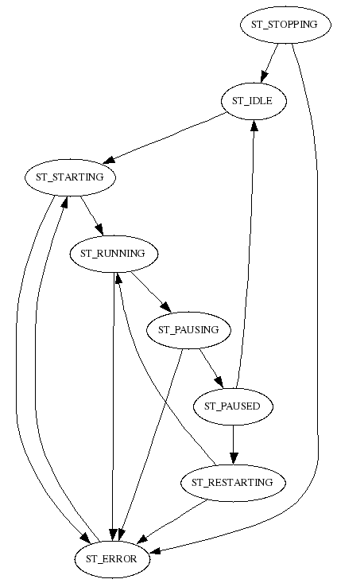Fig 1: 708Workcell.statemachine
TEST ErrorCode = ST_ERROR
TIMEOUT timeBeforePausing ST_PAUSING
SETSTATE ST_PAUSING
ENDTEST
TEST Emergency = ST_POWEROFF
SET errorCode 203
SETSTATE ST_ERROR
ENDTEST
END

State=ST_STOPPING
SETSTATE ST_IDLE
TEST Emergency = ST_POWEROFF
SET errorCode 203
SETSTATE ST_ERROR
ENDTEST
END

State=ST_PAUSING
; dont test for trafficlight :-)
TEST timeBeforePausing = 1
AND BufferPlads = ST_IDLE
AND KasseInLiner = ST_IDLE
AND KasseLift = ST_IDLE
AND LangBufferSkub = ST_IDLE
AND PIDBuffer = ST_IDLE
AND PIDLift = ST_IDLE
AND PIDSkub = ST_IDLE
AND ProductConveyors = ST_IDLE
AND extra1 = ST_IDLE
SETSTATE ST_PAUSED
ENDTEST
TEST Emergency = ST_POWEROFF
SET errorCode 203
SETSTATE ST_ERROR
ENDTEST
END

State=ST_PAUSED
TEST newprogram = 1
SETSTATE ST_IDLE
ELSE
TEST ContinueKnap = ST_HIGH
SET firstRun 0
TIMEOUT timeBeforeRunning ST_RESTARTING
SETSTATE ST_RESTARTING
ENDTEST
ENDTEST
END

State=ST_ERROR
TEST ContinueKnap = ST_HIGH
SET errorCode 0
TIMEOUT timeBeforeRunning ST_STARTING
SETSTATE ST_STARTING
ENDTEST
END

State=ST_RESET
END

State=ST_TIMER
END

708Parent.statemachine
STATEMACHINEVERSION 3
Name=Parent
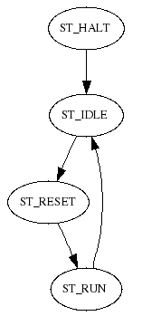Fig 2: 708Parent.statemachine
Link=WorkCell WorkCell

State=ST_HALT
SETSTATE ST_IDLE
END

State=ST_TIMER
END

State=ST_IDLE
TEST WorkCell = ST_STARTING
OR WorkCell = ST_RESTARTING
SETSTATE ST_RESET
ENDTEST
END

State=ST_RUN
TEST WorkCell = ST_IDLE
OR WorkCell = ST_PAUSED
OR WorkCell = ST_PAUSING
OR WorkCell = ST_ERROR
SETSTATE ST_IDLE
ENDTEST
END

State=ST_RESET
SETSTATE ST_RUN
END

708Program.statemachine
Example program:

STATEMACHINEVERSION 3
Name=Program
Link=workcell WorkCell
Value=usersection 0
Const=programidx 1
Value=loadfromleft 0
Value=loadfromright 0
Value=productsfromleft 0
Value=productsfromright 0
Value=newprogram 1
Value=timeMotorInGoDown 0
Value=timeKlapDown 0
Value=noShakeOnLast 0
Value=waitInR3 0
Value=vibrateTime 8000000
Value=manuelt 0
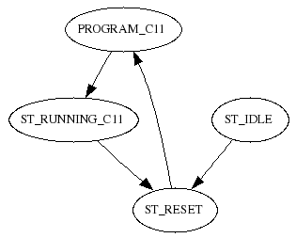fig 3: 708Program.statemachine
Value=kasseStopType 1
Value=secondProdConvOn 0
;programmer
Value=program 0
Item=item C11
Item=itemC11 C11
CPPattern=cppHarndrup Harndrup

State=PROGRAM_C11
SET usersection 0
SET newprogram 1
SET loadfromleft 1
SET loadfromright 0
SET productsfromleft 0
SET productsfromright 1
SET secondProdConvOn 0
SET program 0
SET manuelt 0
SET usersection 1 ; user editable below
;
SETITEM item itemC11
SETCPPATTERN cppattern cppHarndrup
SET timeMotorInGoDown 0
SET timeKlapDown 300000
SET noShakeOnLast 0
SET waitInR3 0
SET vibrateTime 800000
SETSTATE ST_RUNNING_C11
END

State=ST_RUNNING_C11

SET newprogram 0
TEST workcell = ST_IDLE
OR workcell = ST_PAUSED
TEST programidx != program
SETSTATE ST_RESET
ENDTEST
ENDTEST
END

State=ST_TIMER
END

State=ST_HALT
END

State=ST_IDLE
SETSTATE ST_RESET
END

State=ST_RESET
TEST programidx = 0
SETSTATE PROGRAM_C11
ENDTEST
END

708ErrorCode.statemachine
STATEMACHINEVERSION 3
Include=cperrorcode.statemachine
Name=ErrorCode
linkValue=pidbuffer errorCode ServoBuffer
linkValue=pidlift errorCode ServoLift
linkValue=pidskub errorCode ServoSkub
linkValue=remotewatch errorCode IOError

STATEMACHINEVERSION 3
Name=ErrorCode
Link=parent Parent
linkValue=workcell errorCode WorkCell
linkValue=emergency errorCode Emergency
linkValue=tripwatch errorCode TripWatch
linkValue=pidbuffer errorCode PIDBuffer
linkValue=pidlift errorCode PIDLift
linkValue=pidskub errorCode PIDSkub
linkValue=langbufferskub errorCode LangBufferSkub
linkValue=remotewatch errorCode RemoteWatch
linkValue=kasseinliner errorCode KasseInLiner
linkValue=kasselift errorCode KasseLift
linkValue=productcount errorCode ProductCount
linkValue=ioerror errorCode IOError

State=ST_HALT
END

State=ST_TIMER
END

State=ST_IDLE
TEST parent = ST_RESET
SETSTATE ST_RESET
ENDTEST
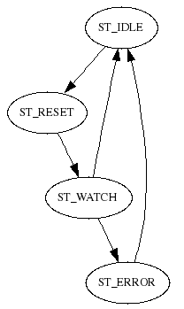fig 4: 708ErrorCode.statemachine
END

State=ST_RESET
SETSTATE ST_WATCH
END

State=ST_WATCH
TEST workcell != 0
OR emergency != 0
OR tripwatch != 0
OR pidbuffer != 0
OR pidlift != 0
OR pidskub != 0
OR langbufferskub != 0
OR remotewatch != 0
OR kasseinliner != 0
OR kasselift != 0
OR productcount != 0
OR ioerror != 0
SETSTATE ST_ERROR
ENDTEST
TEST parent = ST_IDLE
SETSTATE ST_IDLE
ENDTEST
END

State=ST_ERROR
TEST parent = ST_IDLE
SETSTATE ST_IDLE
ENDTEST
END

708ContinueKnap.statemachine
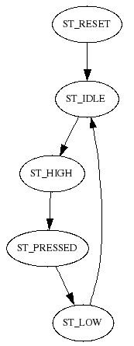fig 5:708ContinueKnap.statemachine
STATEMACHINEVERSION 3
Include=continueknap.statemachine
Name=ContinueKnap
Input=Knap ""
Timeout=TimeoutDelay 2000000

STATEMACHINEVERSION 3
Name=ContinueKnap
Input=Knap "dummyOff"
Const=useKnap 1
Value=knap 0
Timeout=TimeoutDelay 2000000
Timeout=startDelay 0

State=ST_HALT
END

State=ST_TIMER
END

State=ST_IDLE
TEST knap = 1
TIMEOUT startDelay ST_HIGH
SETSTATE ST_TIMER
ELSE
TEST Knap = 1
AND useKnap = 1
TIMEOUT startDelay ST_HIGH
SETSTATE ST_TIMER
ENDTEST
ENDTEST
END

State=ST_HIGH
TIMEOUT TimeoutDelay ST_PRESSED
SETSTATE ST_PRESSED
END

State=ST_PRESSED
TEST TimeoutDelay = 1
SETSTATE ST_LOW
ENDTEST
END

State=ST_LOW
SET knap 0
SETSTATE ST_IDLE
END

State=ST_RESET
SETSTATE ST_IDLE
END

708TrafficLight.statemachine
STATEMACHINEVERSION 3
Include=trafficlight.statemachine
Name=TrafficLight
Output=green "Green Light"
Output=yellow "Yellow Light"
Output=red "dummyOut"
Timeout=blinkRate 500000
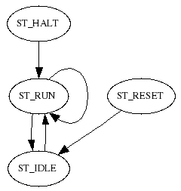fig 6: 708TrafficLight.statemachine
Link=workcell WorkCell
Link=emergency Emergency
Value=OFF 0
Value=ON 1
Value=BLINK 0

STATEMACHINEVERSION 3
Name=TrafficLight
Output=green "Green Light"
Output=yellow "Yellow Light"
Output=red "dummyOut"
Timeout=blinkRate 500000
Link=workcell WorkCell
Link=emergency Emergency
Link=errorcode ErrorCode
Value=OFF 0
Value=ON 1
Value=BLINK 0
Value=error 0
Const=enable 1

State=ST_HALT
TIMEOUT blinkRate ST_RUN
SETSTATE ST_RUN
END

State=ST_TIMER
END

State=ST_IDLE
TEST enable = 1
TIMEOUT blinkRate ST_RUN
SETSTATE ST_RUN
ENDTEST
END

State=ST_RESET
SET error 0
SETSTATE ST_IDLE
END

State=ST_RUN
TEST enable = 0
SETSTATE ST_IDLE
ENDTEST
TEST errorcode = ST_ERROR
SET error 1
ENDTEST
TEST blinkRate = 1
TEST BLINK = ON
SET BLINK OFF
ELSE
SET BLINK ON
ENDTEST
TIMEOUT blinkRate ST_RUN
SETSTATE ST_RUN
ENDTEST
TEST emergency = ST_POWEROFF
SET red ON
SET yellow OFF
SET green OFF
ELSE
TEST workcell = ST_IDLE
SET error 0
SET red OFF
SET yellow ON
SET green OFF
ELSE
TEST workcell = ST_STARTING
OR workcell = ST_RESTARTING
OR workcell = ST_PAUSING
SET red OFF
SET yellow ON
SET green BLINK
ELSE
TEST workcell = ST_RUNNING
SET error 0
SET red OFF
SET yellow OFF
SET green ON
ELSE
TEST workcell = ST_PAUSED
SET red OFF
TEST error = 0
SET yellow BLINK
SET green BLINK
ELSE
SET yellow BLINK
SET green OFF
ENDTEST
ELSE
TEST workcell = ST_ERROR
SET red OFF
SET yellow BLINK
SET green OFF
ELSE
SET red BLINK
SET yellow OFF
SET green OFF
ENDTEST
ENDTEST
ENDTEST
ENDTEST
ENDTEST
ENDTEST
END

708Emergency.statemachine
STATEMACHINEVERSION 3
Include=cpemergency.statemachine
Name=Emergency
Input=EmergencyOK "Emergency OK"
Output=PowerOK "Styrespaending OK"

STATEMACHINEVERSION 3
Name=Emergency
Input=EmergencyOK "dummyOn"
Output=PowerOK "dummyOut"
Value=errorCode 0
Const=errorCode101 101
Timeout=delayOn 1000000
Value=simulate 0

State=ST_TIMER
END
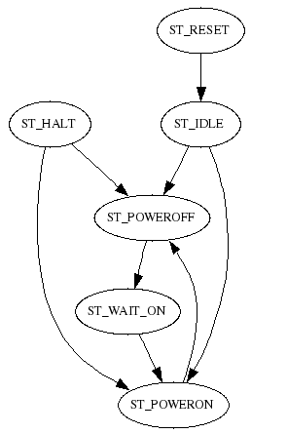fig 7: 708Emergency.statemachine
State=ST_HALT
TEST EmergencyOK = 0
AND simulate = 0
SETSTATE ST_POWEROFF
ELSE
SETSTATE ST_POWERON
ENDTEST
END

State=ST_IDLE
TEST EmergencyOK = 0
AND simulate = 0
SETSTATE ST_POWEROFF
ELSE
SETSTATE ST_POWERON
ENDTEST
END

State=ST_POWEROFF
SET errorCode errorCode101
SET PowerOK 0
TEST EmergencyOK = 1
OR simulate = 1
TIMEOUT delayOn ST_WAIT_ON
SETSTATE ST_WAIT_ON
ENDTEST
END

State=ST_WAIT_ON

TEST delayOn = 1
SETSTATE ST_POWERON
ENDTEST
END

State=ST_POWERON
SET errorCode 0
SET PowerOK 1
TEST EmergencyOK = 0
AND simulate = 0
SETSTATE ST_POWEROFF
ENDTEST
END

State=ST_RESET
SETSTATE ST_IDLE
END

708IOError.statemachine
STATEMACHINEVERSION 3
Include=ioerror.statemachine
Name=IOError
Link=parent Parent
Value=errorCode 0
Value=advantyserror 0
Value=comskerror 0
Value=trioerror 0
Value=loadcellerror 0
Const=ioerrorcode 500

STATEMACHINEVERSION 3
Name=IOError
Link=parent Parent
Value=errorCode 0
Value=advantyserror 0
Value=comskerror 0
Value=trioerror 0
Value=loadcellerror 0
Value=macerror 0
Value=icpconerror 0

; TODO Implement trio error i drivers

State=ST_HALT
END

State=ST_TIMER
END

State=ST_IDLE
TEST advantyserror != 0
SET errorCode 501
ELSETEST comskerror != 0
SET errorCode 502
ELSETEST trioerror != 0
SET errorCode 503
ELSETEST loadcellerror != 0
SET errorCode 504
ELSETEST macerror != 0
SET errorCode 505
ELSETEST icpconerror != 0
SET errorCode 506
ENDTEST
TEST parent = ST_RESET
SET advantyserror 0
SET comskerror 0
SET trioerror 0
SET loadcellerror 0
SET macerror 0
SET errorCode 0
ENDTEST
END

708TripWatch.statemachine
STATEMACHINEVERSION 3
Include=cptripwatch2.statemachine
Name=TripWatch
Input=conveyor2 "ProduktConveyor_2 HZOK"
Input=extra1 "Accumulating Conveyor HZOK"
Const=extra1Pol 0
;** User section **

STATEMACHINEVERSION 3
Name=TripWatch
Input=conveyor1 "ProduktConveyor_1 HZOK"
Input=conveyor2 "dummyOn"
Input=skubberstatus "LangBufferSkub Status"
Input=bufferstatus "BufferPlads Status"
Input=liftstatus "KasseLift Status"
Input=inliner "KasseInliner Motor Tripped"
Input=liftconveyor "KasseLift Conveyor Motor Tripped"
Input=vibrator "KasseLift Vibrator Tripped"
Input=extra1 "dummyOff"
Const=extra1Pol 1
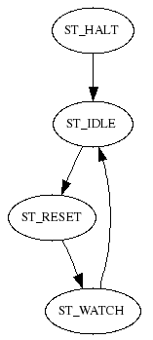fig 8: 708TripWatch.statemachine
Const=extra1ErrorCode 1100
Link=parent Parent
Value=errorCode 0

State=ST_TIMER
END

State=ST_HALT
SETSTATE ST_IDLE
END

State=ST_IDLE
TEST parent = ST_RESET
SET errorCode 0
SETSTATE ST_RESET
ENDTEST
END

State=ST_RESET
SETSTATE ST_WATCH
END

State=ST_WATCH
TEST conveyor1 = 0
OR conveyor2 = 0
SET errorCode 1100
ENDTEST
TEST skubberstatus != 16
AND skubberstatus != 32
AND skubberstatus != 48
AND skubberstatus != 64
AND skubberstatus != 80
AND skubberstatus != 0
SET errorCode 1101
ENDTEST
TEST bufferstatus != 16
AND bufferstatus != 32
AND bufferstatus != 48
AND bufferstatus != 64
AND bufferstatus != 80
AND bufferstatus != 0
SET errorCode 1102
ENDTEST
TEST liftstatus != 16
AND liftstatus != 32
AND liftstatus != 48
AND liftstatus != 64
AND liftstatus != 80
AND liftstatus != 0
SET errorCode 1103
ENDTEST
TEST inliner = 1
SET errorCode 1104
ENDTEST
TEST liftconveyor = 1
SET errorCode 1105
ENDTEST
TEST vibrator = 1
SET errorCode 1106
ENDTEST
TEST extra1 = extra1Pol
SET errorCode extra1ErrorCode
ENDTEST
TEST parent = ST_IDLE
SETSTATE ST_IDLE
ENDTEST
END

Product Handling Statemachines

708ProductConveyors.statemachine
STATEMACHINEVERSION 3
Include=cpproductconveyors.statemachine
Name=ProductConveyors
Input=powerok1 "ProduktConveyor_1 HZOK"
Input=powerok2 "ProduktConveyor_2 HZOK"
Output=Motor1Enable "ProductConveyor1 Motor Enable"
Output=Motor1Setpoint "ProductConveyor1 Setpoint"
Output=Motor2Enable "ProductConveyor2 Motor Enable"
Output=Motor2Setpoint "ProductConveyor2 Setpoint"
Link=CamGenSkub ServoSkub
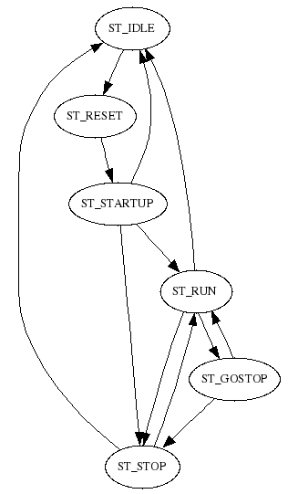fig 9: 708ProductConveyors.statemachine
Const=motor1FreqForward -40.0000
Const=motor1FreqReverse 40.0000
Const=motor2FreqForward -45.0000
Const=motor2FreqReverse 45.0000
Timeout=TimeRunAgain 100000
;** User section **

STATEMACHINEVERSION 3
Name=ProductConveyors
Input=powerok1 "dummyOff"
Input=powerok2 "dummyOff"
Output=Motor1Enable "dummyOut"
Output=Motor1Setpoint "dummyOut"
Output=Motor2Enable "dummyOut"
Output=Motor2Setpoint "dummyOut"
Link=Counter ProductCount
Link=CamGenSkub
Link=parent LangBufferSkub
linkValue=prenumofproducts Counter
linkValue=oldppp Counter
linkValue=productsfromleft Program
linkValue=productsfromright Program
Value=ppp 0
linkValue=secondProdConvOn Program
Const=motor1FreqForward 50.0
Const=motor1FreqReverse -50.0

Const=motor2FreqForward 50.0
Const=motor2FreqReverse -50.0
Timeout=TimeStop 0
Timeout=TimeRunAgain 600000
Input=syncInManuelStop "dummyOff"
Const=useSyncInManuelStop 0
Const=syncInManuelStopPol 1

State=ST_TIMER
END

State=ST_HALT
END

State=ST_IDLE
SET Motor1Enable 0
SET Motor1Setpoint 0.0
SET Motor2Enable 0
SET Motor2Setpoint 0.0
TEST parent = ST_RESET
SETSTATE ST_RESET
ENDTEST
END

State=ST_RESET
SET Motor1Enable 1
SET Motor2Enable 1
SETSTATE ST_STARTUP
END

State=ST_STARTUP
TEST Counter = ST_RUN
OR Counter = ST_RUN_MANUELT
CALC ppp = oldppp + 1
TEST prenumofproducts >= ppp
SETSTATE ST_STOP
ELSE
TEST useSyncInManuelStop = 1
AND syncInManuelStop = syncInManuelStopPol
AND Counter = ST_RUN_MANUELT
SETSTATE ST_STOP
ELSE
TEST CamGenSkub != ST_NOCHOOSETRACK
SETSTATE ST_RUN
ENDTEST
ENDTEST
ENDTEST
ENDTEST
TEST parent = ST_IDLE
SETSTATE ST_IDLE
ENDTEST
END

State=ST_RUN
TEST useSyncInManuelStop = 1
AND syncInManuelStop = syncInManuelStopPol
AND Counter = ST_RUN_MANUELT
SETSTATE ST_STOP
ELSE
CALC ppp = oldppp + 1
TEST prenumofproducts >= ppp
TIMEOUT TimeStop ST_GOSTOP
SETSTATE ST_GOSTOP
ELSE
TEST productsfromleft = 1
AND productsfromright = 1
SET Motor1Enable 1
SET Motor1Setpoint motor1FreqForward
SET Motor2Enable 1
SET Motor2Setpoint motor2FreqForward
ELSE
TEST productsfromleft = 1
TEST secondProdConvOn = 1
SET Motor1Enable 1
SET Motor1Setpoint motor1FreqForward
SET Motor2Enable 1
SET Motor2Setpoint motor2FreqReverse
ELSE
SET Motor1Enable 1
SET Motor1Setpoint motor1FreqForward
SET Motor2Enable 0
SET Motor2Setpoint 0.0
ENDTEST
ELSE
TEST productsfromright = 1
TEST secondProdConvOn = 1
SET Motor1Enable 1
SET Motor1Setpoint motor1FreqReverse
SET Motor2Enable 1
SET Motor2Setpoint motor2FreqForward
ELSE
SET Motor1Enable 0
SET Motor1Setpoint 0.0
SET Motor2Enable 1
SET Motor2Setpoint motor2FreqForward
ENDTEST
ENDTEST
ENDTEST
ENDTEST
ENDTEST
ENDTEST
TEST powerok1 = 0
OR powerok2 = 0
SETSTATE ST_IDLE
ENDTEST
TEST parent = ST_IDLE
SETSTATE ST_IDLE
ENDTEST
END

State=ST_GOSTOP
CALC ppp = oldppp + 1
TEST TimeStop = 1
SETSTATE ST_STOP
ENDTEST
TEST prenumofproducts < ppp
SETSTATE ST_RUN
ENDTEST
END

State=ST_STOP
CALC ppp = oldppp + 1
TEST useSyncInManuelStop = 1
AND syncInManuelStop = syncInManuelStopPol
AND Counter = ST_RUN_MANUELT
SET Motor1Enable 0
SET Motor1Setpoint 0.0
SET Motor2Enable 0
SET Motor2Setpoint 0.0
ELSE
TEST prenumofproducts >= ppp
SET Motor1Enable 0
SET Motor1Setpoint 0.0
SET Motor2Enable 0
SET Motor2Setpoint 0.0
ELSE
TIMEOUT TimeRunAgain ST_RUN
SETSTATE ST_TIMER
ENDTEST
ENDTEST
TEST parent = ST_IDLE
SETSTATE ST_IDLE
ENDTEST
END

708Product1Foto1.statemachine
STATEMACHINEVERSION 3
Include=input.statemachine
Name=Product1Foto1
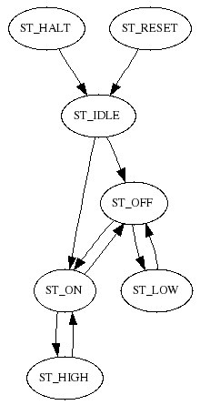fig 10: input.statemachine
Input=input "ProduktConveyor1 Foto1"
Timeout=TimeOn 10000
Timeout=TimeOff 50000
Value=test 0
Link=parent Parent

STATEMACHINEVERSION 3
Name=Input
Input=input "dummyOff"
;how long must input be active before it is recognised as on
Timeout=TimeOn 1000000
;how long must input be not active before it is recognised as off
Timeout=TimeOff 1000000
Value=test 0
Const=active 1

State=ST_HALT
SETSTATE ST_IDLE
END

State=ST_TIMER
END

State=ST_RESET
SETSTATE ST_IDLE
END

State=ST_IDLE
TEST input != active
SET test 0
TIMEOUT TimeOff ST_OFF
SETSTATE ST_OFF
ELSE
SET test 1
TIMEOUT TimeOn ST_ON
SETSTATE ST_ON
ENDTEST
END

State=ST_OFF
TEST input = active
TIMEOUT TimeOn ST_ON
SETSTATE ST_ON
ELSE
TEST TimeOff = 1
AND test = 1
SETSTATE ST_LOW
ENDTEST
ENDTEST
END

State=ST_ON
TEST input != active
TIMEOUT TimeOff ST_OFF
SETSTATE ST_OFF
ELSE
TEST TimeOn = 1
AND test = 0
SETSTATE ST_HIGH
ENDTEST
ENDTEST
END

State=ST_LOW
SET test 0
SETSTATE ST_OFF
END

State=ST_HIGH
SET test 1
SETSTATE ST_ON
END

708Product1Foto2.statemachine
STATEMACHINEVERSION 3
Include=input.statemachine
Name=Product1Foto2
Input=input "ProduktConveyor1 Foto2"
Timeout=TimeOn 100000
Timeout=TimeOff 10000
Value=test 0
Link=parent Parent

708Product2Foto1.statemachine
STATEMACHINEVERSION 3
Include=input.statemachine
Name=Product2Foto1
Input=input "ProduktConveyor2 Foto1"
Timeout=TimeOn 100000
Timeout=TimeOff 100000
Value=test 0
Link=parent Parent

708Product2Foto2.statemachine
STATEMACHINEVERSION 3
Include=input.statemachine
Name=Product2Foto2
Input=input "ProduktConveyor2 Foto2"
Timeout=TimeOn 100000
Timeout=TimeOff 100000
Value=test 0
Link=parent Parent

708AccumulatingConveyorQueFullFoto.statemachine
STATEMACHINEVERSION 3
Include=input.statemachine
Name=AccumulatingConveyorQueFullFoto
Input=input "Accumulating Conveyor Que Full Foto"
Timeout=TimeOn 50000
Timeout=TimeOff 50000
Value=test 0
Link=parent Parent

708AccumulatingConveyor.statemachine
STATEMACHINEVERSION 3
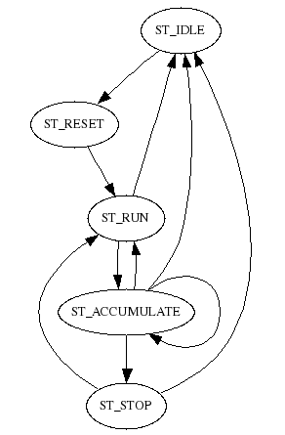fig 11: 708AccumulatingConveyor.statemachine
Name=AccumulatingConveyor
;** Input **
Input=powerok "Accumulating Conveyor HZOK"
;** Output **
Output=motorEnable "Accumulating Conveyor Enable"
Output=motor "Accumulating Conveyor Setpoint"
Output=clap "Accumulating Conveyor Clap"
Output=startulma "Sync Out 1"
;** Link **
Link=queFoto AccumulatingConveyorQueFullFoto
Link=master ProductConveyors
;** linkValue **
;** Const **
Const=motorSpeed 45.0000
;** Value **
Value=queFotoOn 0
;** Timeout **
Timeout=queFullStopTime 1000000

State=ST_HALT
END

State=ST_TIMER
END

State=ST_IDLE
SET motorEnable 0
SET startulma 0
SET motor 0.0
TEST master = ST_RUN
SETSTATE ST_RESET
ENDTEST

END

State=ST_RESET
SETSTATE ST_RUN
END

State=ST_RUN
TEST master = ST_RUN
SET motorEnable 1
SET startulma 1
SET motor motorSpeed
SET clap 0
ELSE
SETSTATE ST_ACCUMULATE
ENDTEST
TEST master = ST_IDLE
OR powerok = 0
SETSTATE ST_IDLE
ENDTEST
END

State=ST_ACCUMULATE
TEST master = ST_RUN
SETSTATE ST_RUN
ELSE
SET clap 1
TEST queFoto = ST_ON
TEST queFotoOn = 0
SET queFotoOn 1
TIMEOUT queFullStopTime ST_ACCUMULATE
SETSTATE ST_ACCUMULATE
ELSE
TEST queFullStopTime = 1
SET queFotoOn 0
SETSTATE ST_STOP
ENDTEST
ENDTEST
ELSE
SET queFotoOn 0
ENDTEST
ENDTEST
TEST master = ST_IDLE
OR powerok = 0
SET queFotoOn 0
SETSTATE ST_IDLE
ENDTEST
END

State=ST_STOP
TEST master = ST_RUN
SETSTATE ST_RUN
ELSE
SET motorEnable 0
SET startulma 0
SET motor 0.0
SET clap 1
ENDTEST
TEST master = ST_IDLE
OR powerok = 0
SETSTATE ST_IDLE
ENDTEST
END

708CPCounter.statemachine
STATEMACHINEVERSION 3
Include=cpcounter.statemachine
Name=CPCounter

STATEMACHINEVERSION 3
Name=CPCounter
Link=foto1 Product1Foto1
Link=foto2 Product2Foto1
Link=parent Parent
linkValue=firstRun WorkCell
linkValue=productsfromleft Program
linkValue=productsfromright Program
Table=avgtime 20.0 AVG
Value=curt 0
Value=temp 0.0
Value=temp2 0.0
Value=now 0.0
Value=avg 0.0
Value=avgtimetol 0.0
Value=prodpermin 0.0
Timeout=MinTime 30000000
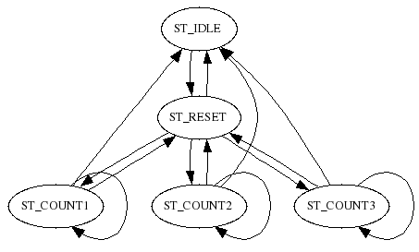fig 12: 708CPCounter.statemachine
State=ST_HALT
END

State=ST_TIMER
END

State=ST_IDLE
TEST parent = ST_RESET
SETSTATE ST_RESET
ENDTEST
END

State=ST_RESET
SET avgtime 600.0
SET avgtime 600.0
SET avgtime 600.0
SET avgtime 600.0

SET avgtime 600.0
SET avgtime 600.0
SET avgtime 600.0
SET avgtime 600.0
SET avgtime 600.0
SET avgtime 600.0
SET avgtime 600.0
SET avgtime 600.0
SET avgtime 600.0
SET avgtime 600.0
SET avgtime 600.0
SET avgtime 600.0
SET avgtime 600.0
SET avgtime 600.0
SET avgtime 600.0
SET avgtime 600.0
SET avg 600.0
SET prodpermin 0.0
TEST productsfromleft = 1
AND productsfromright = 1
TIMEOUT MinTime ST_COUNT1
SETSTATE ST_COUNT1
ELSE
TEST productsfromleft = 1
TIMEOUT MinTime ST_COUNT2
SETSTATE ST_COUNT2
ELSE
TEST productsfromright = 1
TIMEOUT MinTime ST_COUNT3
SETSTATE ST_COUNT3
ELSE
SETSTATE ST_IDLE
ENDTEST
ENDTEST
ENDTEST
END

State=ST_COUNT1
SET curt MinTime
CALC curt = MinTime - curt
CALC now = curt / 1000000.0
TEST foto1 = ST_LOW
AND foto2 = ST_LOW
TIMEOUT MinTime ST_COUNT1
SETSTATE ST_COUNT1
SET avgtime now
SET avgtime now
SET avg avgtime
ELSE
TEST foto1 = ST_LOW
TIMEOUT MinTime ST_COUNT1
SETSTATE ST_COUNT1
SET avgtime now
SET avg avgtime
ELSE
TEST foto2 = ST_LOW
TIMEOUT MinTime ST_COUNT1
SETSTATE ST_COUNT1
SET avgtime now
SET avg avgtime
ELSE
TEST MinTime = 1
SET avg 600.0
SETSTATE ST_RESET
ELSE
SET avg avgtime
ENDTEST
ENDTEST
ENDTEST
ENDTEST
CALC prodpermin = 60.0 / avg
TEST parent = ST_IDLE
SETSTATE ST_IDLE
ENDTEST
END

State=ST_COUNT2
SET curt MinTime
CALC curt = MinTime - curt
CALC now = curt / 1000000.0
TEST foto1 = ST_LOW
TIMEOUT MinTime ST_COUNT2
SETSTATE ST_COUNT2
SET avgtime now
SET avg avgtime
ELSE
TEST MinTime = 1
SET avg 600.0
SETSTATE ST_RESET
ELSE
SET avg avgtime
ENDTEST
ENDTEST
CALC prodpermin = 60.0 / avg
TEST parent = ST_IDLE
SETSTATE ST_IDLE
ENDTEST
END

State=ST_COUNT3
SET curt MinTime
CALC curt = MinTime - curt
CALC now = curt / 1000000.0
TEST foto2 = ST_LOW
TIMEOUT MinTime ST_COUNT3
SETSTATE ST_COUNT3
SET avgtime now
SET avg avgtime
ELSE
TEST MinTime = 1
SET avg 600.0
SETSTATE ST_RESET
ELSE
SET avg avgtime
ENDTEST
ENDTEST
CALC prodpermin = 60.0 / avg
TEST parent = ST_IDLE
SETSTATE ST_IDLE
ENDTEST
END

708ProductCount.statemachine
STATEMACHINEVERSION 3
Include=cpproductcount.statemachine
Name=ProductCount
Link=CamGenSkub ServoSkub
Link=rfoto1 Product1Foto1
Link=rfoto2 Product1Foto2
Link=lfoto1 Product2Foto1
Link=lfoto2 Product2Foto2
;** User section **
Value=superhack_AdjustProdConv1Foto2AndEdit708ProductCount
Value=rfoto2test 1

State=ST_IDLE
TEST parent = ST_RESET
PRINT superhack_AdjustProdConv1Foto2AndEdit708ProductCount
SETSTATE ST_RESET
ENDTEST
END

STATEMACHINEVERSION 3
Name=ProductCount
;** Input **
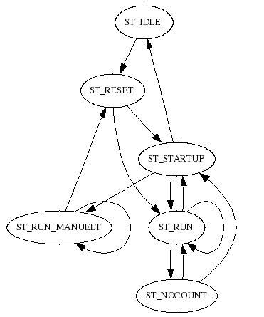fig 13: 708ProductCount.statemachine
;** Output **
;** Link **
Link=Skubber LangBufferSkub
Link=CamGenSkub
Link=parent Parent
Link=KasseLift
Link=lfoto1 Product1Foto1
Link=lfoto2 Product1Foto2
Link=rfoto1 Product2Foto1
Link=rfoto2 Product2Foto2
Link=PushPattern
Link=Conveyors ProductConveyors
;** linkValue **
linkValue=lfoto1test test lfoto1
linkValue=lfoto2test test lfoto2
linkValue=rfoto1test test rfoto1
linkValue=rfoto2test test rfoto2
linkValue=curpm CamGenSkub
linkValue=curppp PushPattern
linkValue=productsfromleft Program
linkValue=productsfromright Program
linkValue=firstRun WorkCell
linkValue=manuelt Program
linkValue=doFakeProducts WorkCell
;** Table **
;** Item **
;** Const **
Const=freepmstay 350
Const=freepmforward 200
;** Value **
Value=errorCode 0
Value=message 0
Value=numofproducts 0
Value=prenumofproducts 0
Value=totcount 0
Value=lowcount 0
Value=pushtotcount 0
Value=pushing 0
Value=oldppp 0
Value=timeStopOn 0
;** Timeout **
Timeout=fakeProductRate 2000000
Timeout=TimeStartUp 1500000
Timeout=maxProductLengthStopTime 2000000
Timeout=TimeStop 1000000

State=ST_TIMER
END

State=ST_HALT
END

State=ST_IDLE
TEST parent = ST_RESET
SETSTATE ST_RESET
ENDTEST
END

State=ST_RESET
SET errorCode 0
SET numofproducts 0
SET totcount 0
SET lowcount 0
SET pushtotcount 0
TEST firstRun = 1
TIMEOUT TimeStartUp ST_STARTUP
SETSTATE ST_STARTUP
ELSE
TIMEOUT fakeProductRate ST_RUN
SETSTATE ST_RUN
ENDTEST
END

State=ST_STARTUP
SET oldppp curppp
TEST TimeStartUp = 1
TIMEOUT fakeProductRate ST_RUN
SETSTATE ST_RUN
TEST productsfromleft = 1
AND productsfromright = 1
TEST lfoto1test = 0
OR lfoto2test = 0
OR rfoto1test = 0
OR rfoto2test = 0
SET errorCode 1055
SETSTATE ST_IDLE
ENDTEST
SET numofproducts 0
SET totcount 0
SET pushtotcount 0
SET prenumofproducts numofproducts
ELSE
TEST productsfromleft = 1
TEST lfoto1test = 0
OR lfoto2test = 0
SET errorCode 1055
SETSTATE ST_IDLE
ENDTEST
SET numofproducts 0
SET totcount 0
SET pushtotcount 0
SET prenumofproducts numofproducts
ELSE
TEST productsfromright = 1
TEST rfoto1test = 0
OR rfoto2test = 0
SET errorCode 1055
SETSTATE ST_IDLE
ENDTEST
SET numofproducts 0
SET totcount 0
SET pushtotcount 0
SET prenumofproducts numofproducts
ENDTEST
ENDTEST
ENDTEST
TEST manuelt = 1
SET errorCode 0
SETSTATE ST_RUN_MANUELT
ENDTEST
ENDTEST
END

State=ST_RUN
TEST lfoto1 = ST_HIGH
AND productsfromleft = 1
CALC numofproducts = numofproducts + 1
SET prenumofproducts numofproducts
CALC totcount = pushtotcount + numofproducts
CALC lowcount = lowcount + 1
ENDTEST
TEST lfoto1 = ST_LOW
AND productsfromleft = 1
CALC prenumofproducts = numofproducts + 1
ENDTEST
TEST rfoto1 = ST_HIGH
AND productsfromright = 1
CALC numofproducts = numofproducts + 1
SET prenumofproducts numofproducts
CALC totcount = pushtotcount + numofproducts
CALC lowcount = lowcount + 1
ENDTEST
TEST rfoto1 = ST_LOW
AND productsfromright = 1
CALC prenumofproducts = numofproducts + 1
ENDTEST
TEST pushing = 0
TEST Skubber = ST_FORWARD
TEST curpm > freepmforward
CALC numofproducts = numofproducts - oldppp
CALC prenumofproducts = prenumofproducts - oldppp
CALC pushtotcount = pushtotcount + oldppp
CALC totcount = pushtotcount + numofproducts
SET oldppp curppp
SET pushing 1
ENDTEST
ELSE
TEST Skubber = ST_FORWARDSTAY
TEST curpm > freepmstay
CALC numofproducts = numofproducts - oldppp
CALC prenumofproducts = prenumofproducts - oldppp
CALC pushtotcount = pushtotcount + oldppp
CALC totcount = pushtotcount + numofproducts
SET oldppp curppp
SET pushing 1
ENDTEST
ENDTEST
ENDTEST
ELSE
TEST Skubber != ST_FORWARD
AND Skubber != ST_FORWARDSTAY
AND Skubber != ST_STAY_FINISH
SET pushing 0
ENDTEST
ENDTEST
TEST doFakeProducts = 1
TEST fakeProductRate = 1
CALC numofproducts = numofproducts + 1
SET prenumofproducts numofproducts
CALC totcount = pushtotcount + numofproducts
CALC lowcount = lowcount + 1
TIMEOUT fakeProductRate ST_RUN
SETSTATE ST_RUN
ENDTEST
TEST KasseLift = ST_READY
SET numofproducts 0
SET totcount 0
SET pushtotcount 0
SET prenumofproducts numofproducts
SET doFakeProducts 0
ENDTEST
ENDTEST
TEST firstRun = 1
AND parent = ST_RESET
SET timeStopOn 0
TIMEOUT TimeStartUp ST_STARTUP
SETSTATE ST_STARTUP
ENDTEST
TEST Conveyors = ST_IDLE
TEST timeStopOn = 0
SET timeStopOn 1
TIMEOUT TimeStop ST_RUN
SETSTATE ST_RUN
ELSE
TEST TimeStop = 1
SET timeStopOn 0
SETSTATE ST_NOCOUNT
ENDTEST
ENDTEST
ENDTEST
END

State=ST_NOCOUNT
TEST parent = ST_RESET
TEST firstRun = 1
TIMEOUT TimeStartUp ST_STARTUP
SETSTATE ST_STARTUP
ELSE
SETSTATE ST_RUN
ENDTEST
ENDTEST
END

State=ST_RUN_MANUELT
TEST productsfromright = 1
TEST rfoto1 = ST_OFF
TEST maxProductLengthStopTime = 1
;hack that stops ProductConveyor
SET prenumofproducts 100
SET message 1000
ELSE
SET prenumofproducts 0
SET message 0
ENDTEST
ELSE
TEST rfoto1 = ST_ON
SET prenumofproducts 0
TIMEOUT maxProductLengthStopTime ST_RUN_MANUELT
SETSTATE ST_RUN_MANUELT
ENDTEST
ENDTEST
ELSE
SET prenumofproducts 0
TIMEOUT maxProductLengthStopTime ST_RUN_MANUELT
SETSTATE ST_RUN_MANUELT
ENDTEST
TEST firstRun = 1
AND parent = ST_RESET
SET message 0
SETSTATE ST_RESET
ENDTEST
END

708PushPattern.statemachine
STATEMACHINEVERSION 3
Include=cppushpattern2.statemachine
Name=PushPattern

STATEMACHINEVERSION 3
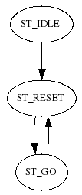fig 14: 708PushPattern.statemachine
Name=PushPattern
Link=Program
Link=ProductCount
Link=Skubber LangBufferSkub
Link=parent Parent
linkValue=firstRun WorkCell
linkValue=numpush Skubber
linkValue=layers bufferlayers BufferPlads
linkValue=cppattern Program
Value=curppp 0
Value=curpacc 0
Value=curpspeed 0
Value=gettime 350000
Value=maxpush 2
Value=maxlayers 0
;pushshort not supported by cppattern
Value=pushshortleft 0
Value=pushshortright 0

State=ST_TIMER
END

State=ST_HALT
END

State=ST_IDLE
TEST ProductCount = ST_RESET
SETSTATE ST_RESET
ENDTEST
END

State=ST_RESET
SETSTATE ST_GO
END

State=ST_GO
SET maxlayers cppattern.maxlayers
SET cppattern.layeridx layers
SET maxpush cppattern.maxpush
SET gettime cppattern.gettime
SET cppattern.pppidx numpush
SET curppp cppattern.ppp
SET curpacc cppattern.pacc
SET curpspeed cppattern.pspeed
TEST firstRun = 1
AND parent = ST_RESET
SETSTATE ST_RESET
ENDTEST
END

Servo Statemachines

708ServoSkub.statemachine
STATEMACHINEVERSION 3
Include=cpservoskub.statemachine
Name=ServoSkub
;** User section **
Const=cruise_speed 1500.0000
Const=acceleration 3500.0000

STATEMACHINEVERSION 3
Name=ServoSkub
Link=Master LangBufferSkub
Link=parent Parent
Input=homesensor "LangBufferSkub HomeSensor"
Output=Mode "LangBufferSkub Mode"
Output=setpoint "LangBufferSkub MacSetpoint"
Output=vsoll "LangBufferSkub Maxvel"
Output=asoll "LangBufferSkub Maxacc"
Output=set_curpos "LangBufferSkub Curpos"
Output=kvout "LangBufferSkub Load Factor"
Output=set_status "LangBufferSkub Status"
Input=temperature "LangBufferSkub Temperature"
Input=Inpos "LangBufferSkub IN_POS"
Input=curpos "LangBufferSkub Curpos"
Input=curvel "LangBufferSkub Curvel"
Input=status "LangBufferSkub Status"
Value=errorCode 0
Value=curpm 0.0
Const=posBackOffset 2000
Const=posForwardOffset -12000
Const=posRound 240000
Const=loadfactor 1.8000
Value=posRoundHalf 120000
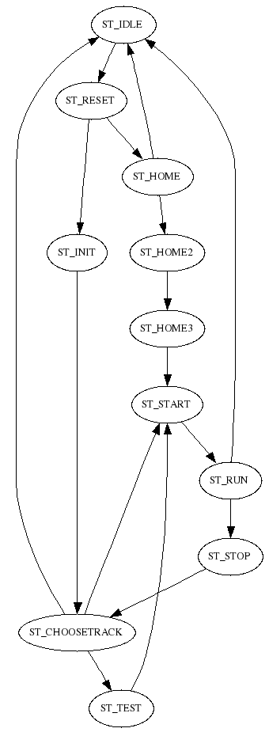fig 15: 708ServoSkub.statemachine
Value=homed 0
Value=infwdpos 0
Value=temp 0
Value=ftemp 0.0
Const=homeSensorPol 0
Const=home_speed 300.0000
Const=acceleration 4500.0000
Const=cruise_speed 2750.0000
Const=testmode 0
Value=teststate 0
Value=distance 0.0
Value=startpos 0.0
Timeout=TimeTest 1000000
Timeout=TimeCmdDelay 500000
Timeout=TimeStartMax 1000000
Timeout=TimeHome 10000000

State=ST_TIMER
END

State=ST_HALT
END

State=ST_IDLE
TEST parent = ST_RESET
TEST status != 16
AND status != 32
AND status != 48
AND status != 64
AND status != 80
AND status != 0
SET set_status 0
ENDTEST
SET errorCode 0
SETSTATE ST_RESET
ENDTEST
END

State=ST_RESET
SET kvout loadfactor
CALC posRoundHalf = posRound / 2
SET asoll acceleration
TEST homed = 0
SET vsoll home_speed
SET Mode 1
TIMEOUT TimeHome ST_HOME
SETSTATE ST_HOME
ELSE
SET vsoll cruise_speed
SET setpoint curpos
TIMEOUT TimeCmdDelay ST_INIT
SETSTATE ST_INIT
ENDTEST
END

State=ST_HOME
TEST homesensor = homeSensorPol
SET Mode 0
TIMEOUT TimeCmdDelay ST_HOME2
SETSTATE ST_HOME2
ELSETEST TimeHome = 1
SET errorCode 1050
SET Mode 0
SETSTATE ST_IDLE
ENDTEST
END

State=ST_HOME2
TEST TimeCmdDelay = 1
SET setpoint 0
SET set_curpos 0
SET homed 1
SET Mode 2
TIMEOUT TimeCmdDelay ST_HOME3
SETSTATE ST_HOME3
ENDTEST
END

State=ST_HOME3
TEST TimeCmdDelay = 1
SET vsoll cruise_speed
SET setpoint posBackOffset
SET startpos curpos
SET distance posBackOffset
TIMEOUT TimeStartMax ST_START
SETSTATE ST_START
ENDTEST
END

State=ST_INIT
TEST TimeCmdDelay = 1
SET Mode 2
SETSTATE ST_CHOOSETRACK
ENDTEST
END

State=ST_NOCHOOSETRACK
END

State=ST_CHOOSETRACK
TEST Master = ST_IDLE
AND testmode = 0
SET Mode 0
SETSTATE ST_IDLE
ELSETEST Master = ST_BEGINBACK
TEST infwdpos = 1
CALC setpoint = posRound + posBackOffset
ELSE
SET setpoint posBackOffset
ENDTEST
SET startpos curpos
CALC distance = setpoint - curpos
TIMEOUT TimeStartMax ST_START
SETSTATE ST_START
ELSETEST Master = ST_BEGINFORWARDSTAY
TEST infwdpos = 1
CALC temp = posRound + posRoundHalf
CALC setpoint = posForwardOffset + temp
ELSE
CALC setpoint = posForwardOffset + posRoundHalf
ENDTEST
SET startpos curpos
CALC distance = setpoint - curpos
TIMEOUT TimeStartMax ST_START
SETSTATE ST_START
ELSETEST Master = ST_BEGINFORWARD
TEST infwdpos = 1
SET setpoint posBackOffset
SET infwdpos 0
ELSE
CALC setpoint = posRound + posBackOffset
SET infwdpos 1
ENDTEST
SET startpos curpos
CALC distance = setpoint - curpos
TIMEOUT TimeStartMax ST_START
SETSTATE ST_START
ELSETEST testmode = 1
TIMEOUT TimeTest ST_TEST
SETSTATE ST_TEST
ENDTEST
END

State=ST_TEST
TEST TimeTest = 1
TEST teststate = 0
SET teststate 1
;forward
TEST infwdpos = 1
SET setpoint posBackOffset
SET infwdpos 0
ELSE
CALC setpoint = posRound + posBackOffset
SET infwdpos 1
ENDTEST
SET startpos curpos
CALC distance = setpoint - curpos
TIMEOUT TimeStartMax ST_START
SETSTATE ST_START
ELSETEST teststate = 1
SET teststate 2
;forwardstay
TEST infwdpos = 1
CALC temp = posRound + posRoundHalf
CALC setpoint = posForwardOffset + temp
ELSE
CALC setpoint = posForwardOffset + posRoundHalf
ENDTEST
SET startpos curpos
CALC distance = setpoint - curpos
TIMEOUT TimeStartMax ST_START
SETSTATE ST_START
ELSETEST teststate = 2
SET teststate 0
;back
TEST infwdpos = 1
CALC setpoint = posRound + posBackOffset
ELSE
SET setpoint posBackOffset
ENDTEST
SET startpos curpos
CALC distance = setpoint - curpos
TIMEOUT TimeStartMax ST_START
SETSTATE ST_START
ENDTEST
ENDTEST
END

State=ST_STOP
SET curpm 1000.0
SETSTATE ST_CHOOSETRACK
END

State=ST_START
SET curpm 0.0
TEST Inpos = 0
OR TimeStartMax = 1
SETSTATE ST_RUN
ENDTEST
END

State=ST_RUN
CALC curpm = curpos - startpos
CALC curpm = curpm / distance
CALC curpm = curpm * 1000.0
TEST Inpos = 1
SETSTATE ST_STOP
ENDTEST
TEST status != 16
AND status != 32
AND status != 48
AND status != 64
AND status != 80
AND status != 0
SET Mode 0
SET homed 0
TIMEOUT TimeCmdDelay ST_IDLE
SETSTATE ST_TIMER
ENDTEST
END

708LangBufferSkub.statemachine
STATEMACHINEVERSION 3
Include=cplangbufferskub.statemachine
Name=LangBufferSkub
Link=CamGen ServoSkub
linkValue=curpm ServoSkub
Const=klapindpm 250
Const=klapudpm 850
Timeout=TimeWaitBack 0
;** User section **

STATEMACHINEVERSION 3
Name=LangBufferSkub
;** Input **
Input=klapinde "LangBufferSkub Klap-"
;** Output **

Output=klap "LangBufferSkub Klap"
;** Link **
Link=CamGen CamGenSkub
Link=pstate ProductState
Link=Counter ProductCount
Link=PushPattern
Link=Conveyors ProductConveyors
Link=bplads BufferPlads
Link=parent Parent
;** linkValue **
linkValue=firstRun WorkCell
linkValue=curpm CamGen
linkValue=maxpush PushPattern
linkValue=gettime PushPattern
linkValue=curppp PushPattern
linkValue=timeKlapDown Program
linkValue=bufferstartingup startingup bplads
linkValue=full bplads
linkValue=numofproducts Counter
;** Table **
;** Item **
;** Const **
Const=klapindpm 350
Const=klapudpm 900
;** Value **
Value=numpush 0
Value=remaining 0
Value=startingup 0
Value=forwardstay 0
Value=errorCode 0
;** Timeout **
Timeout=TimeWaitBack 0
Timeout=TimeKlapDown 300000
Timeout=TimeGet 0

State=ST_TIMER
END

State=ST_HALT
END

State=ST_IDLE
SET klap 0
TEST parent = ST_RESET
SET errorCode 0
SETSTATE ST_RESET
ENDTEST
END

State=ST_RESET
SET TimeKlapDown timeKlapDown
TEST firstRun = 1
SET forwardstay 0
SET numpush 0
ENDTEST
SET startingup 1
TEST forwardstay = 0
SET klap 0
SETSTATE ST_BEGINBACK
ELSE
SET klap 1
SET numpush 0
TIMEOUT TimeKlapDown ST_STAY_FINISH
SETSTATE ST_STAY_FINISH
ENDTEST
END

State=ST_STARTUP
SET startingup 0
TEST Counter = ST_RUN
OR Counter = ST_RUN_MANUELT
SETSTATE ST_WAIT
ENDTEST
TEST parent = ST_IDLE
SETSTATE ST_IDLE
ENDTEST
END

State=ST_WAIT
SET klap 1
TEST numofproducts >= curppp
AND Counter = ST_RUN
AND PushPattern = ST_GO
TEST Conveyors = ST_RUN
OR Conveyors = ST_GOSTOP
; start timer
; hvis bånd stopper før timer udløber -> for tæt
SET TimeGet gettime
TIMEOUT TimeGet ST_WAIT2
SETSTATE ST_WAIT2
ELSETEST Conveyors = ST_STOP
SETSTATE ST_WAIT3
ENDTEST
ENDTEST
TEST parent = ST_IDLE
SETSTATE ST_IDLE
ENDTEST
END

State=ST_WAIT2
TEST TimeGet = 1
TEST bplads = ST_WAITPUSH
OR bufferstartingup = 0
AND bplads = ST_GOCLOSE
CALC remaining = maxpush - numpush
TEST remaining <= 1
SETSTATE ST_BEGINFORWARDSTAY
ELSE
SETSTATE ST_BEGINFORWARD
ENDTEST
ENDTEST
ELSETEST Conveyors = ST_STOP
SET errorCode 1011
SETSTATE ST_IDLE
ENDTEST
TEST parent = ST_IDLE
SETSTATE ST_IDLE
ENDTEST
END

State=ST_WAIT3
TEST bplads = ST_WAITPUSH
OR bufferstartingup = 0
AND bplads = ST_GOCLOSE
CALC remaining = maxpush - numpush
TEST remaining <= 1
SETSTATE ST_BEGINFORWARDSTAY
ELSE
SETSTATE ST_BEGINFORWARD
ENDTEST
ENDTEST
TEST parent = ST_IDLE
SETSTATE ST_IDLE
ENDTEST
END

State=ST_BEGINFORWARD
TEST CamGen = ST_START
CALC numpush = numpush + 1
SETSTATE ST_FORWARD
ENDTEST
TEST parent = ST_IDLE
SETSTATE ST_IDLE
ENDTEST
END

State=ST_BEGINFORWARDSTAY
TEST CamGen = ST_START
SET numpush 0
SETSTATE ST_FORWARDSTAY
ENDTEST
TEST parent = ST_IDLE
SETSTATE ST_IDLE
ENDTEST
END

State=ST_FORWARD
TEST curpm > klapindpm
AND curpm < klapudpm
SET klap 0
ELSE
SET klap 1
ENDTEST
TEST CamGen = ST_STOP
SETSTATE ST_WAIT
ENDTEST
TEST CamGen = ST_NOCHOOSETRACK
OR CamGen = ST_IDLE
SETSTATE ST_IDLE
ENDTEST
END

State=ST_FORWARDSTAY
SET klap 1
TEST CamGen = ST_STOP
TIMEOUT TimeKlapDown ST_STAY_FINISH
SETSTATE ST_STAY_FINISH
ENDTEST
TEST CamGen = ST_NOCHOOSETRACK
OR CamGen = ST_IDLE
SETSTATE ST_IDLE
ENDTEST
END

;TimeKlapDown should be < time to open shutters of BufferPlads (which is roughly 350000 us)

State=ST_STAY_FINISH
SET forwardstay 1
SET numpush 0
TEST bplads = ST_OPEN
OR TimeKlapDown = 1
SET forwardstay 0
SET klap 0
TIMEOUT TimeWaitBack ST_BEGINBACK
SETSTATE ST_TIMER
ENDTEST
TEST parent = ST_IDLE
SETSTATE ST_IDLE
ENDTEST
END

State=ST_BEGINBACK
SET klap 0
TEST CamGen = ST_START
SETSTATE ST_GOBACK
ENDTEST
TEST parent = ST_IDLE
SETSTATE ST_IDLE
ENDTEST
END

State=ST_GOBACK
SET klap 0
TEST startingup = 0
AND curpm > klapudpm
SET klap 1
ENDTEST
TEST CamGen = ST_STOP
TEST startingup = 1
SETSTATE ST_STARTUP
ELSE
SETSTATE ST_WAIT
ENDTEST
ENDTEST
TEST CamGen = ST_NOCHOOSETRACK
OR CamGen = ST_IDLE
SETSTATE ST_IDLE
ENDTEST
END
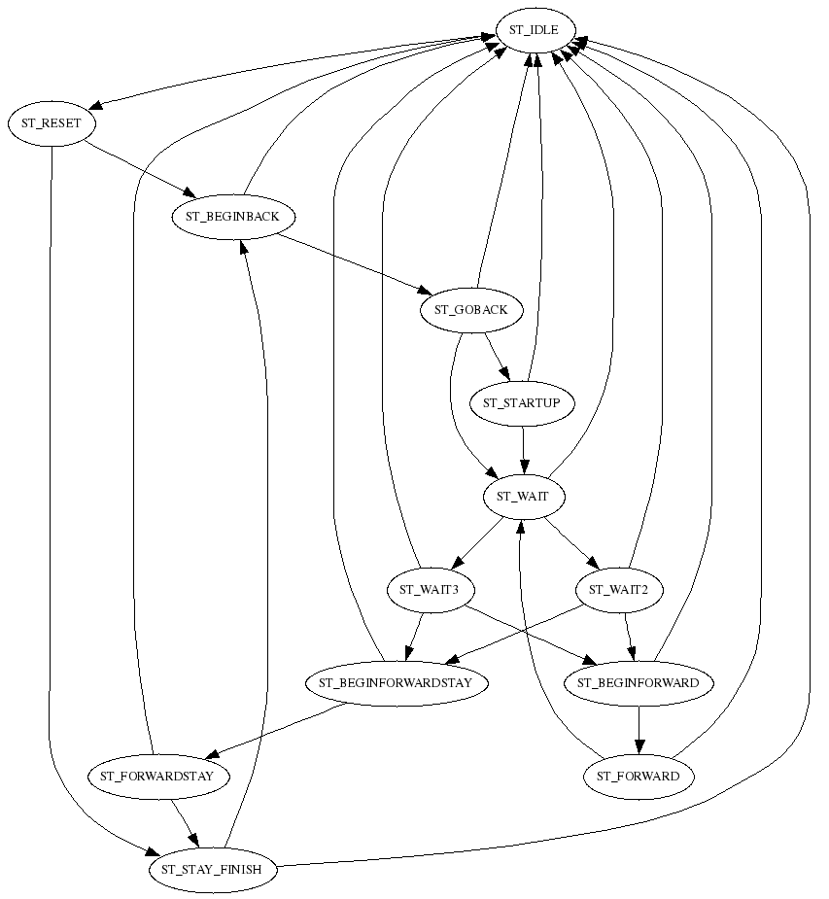fig 16: 708LangBufferSkub.statemachine

708ServoBuffer.statemachine
STATEMACHINEVERSION 3
Include=cpservobuffer.statemachine
Name=ServoBuffer
;** User section **
Const=home_speed 550.0000

STATEMACHINEVERSION 3
Name=ServoBuffer
Link=Master BufferPlads
fig 17: 708ServoBuffer.statemachine
Link=parent Parent
Input=homesensor "BufferPlads HomeSensor"
Output=Mode "BufferPlads Mode"
Output=setpoint "BufferPlads MacSetpoint"
Output=vsoll "BufferPlads Maxvel"
Output=asoll "BufferPlads Maxacc"
Output=set_curpos "BufferPlads Curpos"
Output=kvout "BufferPlads Load Factor"
Output=set_status "BufferPlads Status"
Input=temperature "BufferPlads Temperature"
Input=Inpos "BufferPlads IN_POS"
Input=curpos "BufferPlads Curpos"
Input=curvel "BufferPlads Curvel"
Input=status "BufferPlads Status"
Value=errorCode 0
Value=curpm 0.0
Const=posBackOffset 3000
Const=posForwardOffset 97000
Const=loadfactor 2.5000
Value=homed 0
Const=homeSensorPol 0
Const=home_speed 400.0000
Const=acceleration 35000.0000
Const=cruise_speed 2700.0000
Const=testmode 0
Value=teststate 0
Value=distance 0.0
Value=startpos 0.0
Timeout=TimeTest 500000
Timeout=TimeCmdDelay 500000
Timeout=TimeStartMax 500000
Timeout=TimeHome 10000000

State=ST_TIMER
END

State=ST_HALT
END

State=ST_IDLE
TEST parent = ST_RESET
TEST status != 16
AND status != 32
AND status != 48
AND status != 64
AND status != 80
AND status != 0
SET set_status 0
ENDTEST
SET errorCode 0
SETSTATE ST_RESET
ENDTEST
END

State=ST_RESET
SET kvout loadfactor
SET asoll acceleration
TEST homed = 0
SET vsoll home_speed
SET Mode 1
TIMEOUT TimeHome ST_HOME
SETSTATE ST_HOME
ELSE
SET vsoll cruise_speed
SET setpoint curpos
TIMEOUT TimeCmdDelay ST_INIT
SETSTATE ST_INIT
ENDTEST
END

State=ST_HOME
TEST homesensor = homeSensorPol
SET Mode 0
TIMEOUT TimeCmdDelay ST_HOME2
SETSTATE ST_HOME2
ELSETEST TimeHome = 1
SET errorCode 1051
SET Mode 0
SETSTATE ST_IDLE
ENDTEST
END

State=ST_HOME2
TEST TimeCmdDelay = 1
SET setpoint 0
SET set_curpos 0
SET homed 1
SET Mode 2
TIMEOUT TimeCmdDelay ST_HOME3
SETSTATE ST_HOME3
ENDTEST
END

State=ST_HOME3
TEST TimeCmdDelay = 1
SET vsoll cruise_speed
SET setpoint posBackOffset
SET startpos curpos
SET distance posBackOffset
TIMEOUT TimeStartMax ST_START
SETSTATE ST_START
ENDTEST
END

State=ST_INIT
TEST TimeCmdDelay = 1
SET Mode 2
SETSTATE ST_CHOOSETRACK
ENDTEST
END

State=ST_NOCHOOSETRACK
END

State=ST_CHOOSETRACK
TEST Master = ST_IDLE
AND testmode = 0
SET Mode 0
SETSTATE ST_IDLE
ELSETEST Master = ST_BEGINCLOSE
SET setpoint posBackOffset
SET startpos curpos
CALC distance = setpoint - curpos
TIMEOUT TimeStartMax ST_START
SETSTATE ST_START
ELSETEST Master = ST_BEGINOPEN
SET setpoint posForwardOffset
SET startpos curpos
CALC distance = setpoint - curpos
TIMEOUT TimeStartMax ST_START
SETSTATE ST_START
ELSETEST testmode = 1
TIMEOUT TimeTest ST_TEST
SETSTATE ST_TEST
ENDTEST
END

State=ST_TEST
TEST TimeTest = 1
TEST teststate = 0
SET teststate 1
;forward
SET setpoint posForwardOffset
SET startpos curpos
CALC distance = setpoint - curpos
TIMEOUT TimeStartMax ST_START
SETSTATE ST_START
ELSETEST teststate = 1
SET teststate 0
;back
SET setpoint posBackOffset
SET startpos curpos
CALC distance = setpoint - curpos
TIMEOUT TimeStartMax ST_START
SETSTATE ST_START
ENDTEST
ENDTEST
END

State=ST_STOP
SET curpm 1000.0
SETSTATE ST_CHOOSETRACK
END

State=ST_START
SET curpm 0.0
TEST Inpos = 0
OR TimeStartMax = 1
SETSTATE ST_RUN
ENDTEST
END

State=ST_RUN
CALC curpm = curpos - startpos
CALC curpm = curpm / distance
CALC curpm = curpm * 1000.0
TEST Inpos = 1
SETSTATE ST_STOP
ENDTEST
TEST status != 16
AND status != 32
AND status != 48
AND status != 64
AND status != 80
AND status != 0
SET Mode 0
SET homed 0
TIMEOUT TimeCmdDelay ST_IDLE
SETSTATE ST_TIMER
ENDTEST
END

708BufferPlads.statemachine
STATEMACHINEVERSION 3
Include=cpbufferplads.statemachine
Name=BufferPlads
Link=CamGen ServoBuffer
Link=CemGenSkub ServoSkub
Link=CamGenLift ServoLift
linkValue=curpmskub curpm ServoSkub
linkValue=liftFree ServoLift
;** User section **
Timeout=WaitLeftRightKortSkub 300000
Timeout=WaitKortSkub 100000

STATEMACHINEVERSION 3
Name=BufferPlads
;** Input **
Input=kortskubleftinde "KortBufferSkub Left Inde"
Input=kortskubrightinde "KortBufferSkub Right Inde"
;** Output **
Output=kortskubleft1 "KortBufferSkubber Left 1"
Output=kortskubleft2 "KortBufferSkubber Left 2"
Output=kortskubright1 "KortBufferSkubber Right 1"
Output=kortskubright2 "KortBufferSkubber Right 2"
;** Link **
Link=KasseLift
Link=CamGen CamGenBuffer
Link=CamGenSkub

Link=CamGenLift
Link=Skubber LangBufferSkub
;** linkValue **
linkValue=firstRun WorkCell
linkValue=curpmskub curpm CamGenSkub
linkValue=liftFree CamGenLift
linkValue=pushshortleft PushPattern
linkValue=pushshortright PushPattern
linkValue=numpush LangBufferSkub
linkValue=layers KasseLift
linkValue=maxlayers PushPattern
;** Const **
Const=KortSkubpm 900
;** Value **
Value=full 0
Value=startingup 0
Value=emptyflag 0
Value=bufferlayers 0
;** Timeout **
Timeout=WaitKortSkub 100000
Timeout=WaitLeftRightKortSkub 300000
Timeout=TimeOpen 0

State=ST_TIMER
END

State=ST_HALT
END

State=ST_IDLE
SET kortskubleft1 0
SET kortskubleft2 0
SET kortskubright1 0
SET kortskubright2 0
TEST Skubber = ST_RESET
SETSTATE ST_RESET
ENDTEST
END

State=ST_RESET
TEST firstRun = 1
SET full 0
SET emptyflag 0
SET bufferlayers 0
ENDTEST
SET startingup 1
TEST CamGen = ST_CHOOSETRACK
SETSTATE ST_BEGINCLOSE
ENDTEST
TEST Skubber = ST_IDLE
SETSTATE ST_IDLE
ENDTEST
END

State=ST_STARTUP
SET startingup 0
TEST full = 0
SETSTATE ST_WAITPUSH
ELSE
SET kortskubleft1 1
SET kortskubleft2 1
SET kortskubright1 1
SET kortskubright2 1
TIMEOUT WaitKortSkub ST_DUMP
SETSTATE ST_DUMP
ENDTEST
END

State=ST_WAITPUSH
TEST Skubber = ST_FORWARD
SETSTATE ST_GETPUSH
ELSE
TEST Skubber = ST_FORWARDSTAY
SETSTATE ST_GETFULL
ENDTEST
ENDTEST
TEST Skubber = ST_IDLE
SETSTATE ST_IDLE
ENDTEST
END

State=ST_GETPUSH
TEST curpmskub > 500
TEST numpush = pushshortleft
AND pushshortleft != 0
SET kortskubleft1 1
SET kortskubleft2 1
TIMEOUT WaitLeftRightKortSkub ST_PUSHSHORT
SETSTATE ST_PUSHSHORT
ENDTEST
TEST numpush = pushshortright
AND pushshortright != 0
SET kortskubright1 1
SET kortskubright2 1
TIMEOUT WaitLeftRightKortSkub ST_PUSHSHORT
SETSTATE ST_PUSHSHORT
ENDTEST
ENDTEST
TEST Skubber != ST_FORWARD
SETSTATE ST_WAITPUSH
ENDTEST
END

State=ST_PUSHSHORT
TEST WaitLeftRightKortSkub = 1
SET kortskubleft1 0
SET kortskubleft2 0
SET kortskubright1 0
SET kortskubright2 0
ENDTEST
TEST Skubber != ST_FORWARD
SET kortskubleft1 0
SET kortskubleft2 0
SET kortskubright1 0
SET kortskubright2 0
SETSTATE ST_WAITPUSH
ENDTEST
END

State=ST_GETFULL
TEST curpmskub > KortSkubpm
SET kortskubleft1 1
SET kortskubleft2 1
SET kortskubright1 1
SET kortskubright2 1
ENDTEST
TEST Skubber = ST_STAY_FINISH
SET full 1
CALC bufferlayers = layers + 1
TEST bufferlayers >= maxlayers
SET bufferlayers 0
ENDTEST
SET emptyflag 0
SET kortskubleft1 1
SET kortskubleft2 1
SET kortskubright1 1
SET kortskubright2 1
TIMEOUT WaitKortSkub ST_DUMP
SETSTATE ST_DUMP
ENDTEST
END

State=ST_DUMP
TEST CamGen = ST_CHOOSETRACK
TEST WaitKortSkub = 1
SET kortskubleft1 1
SET kortskubleft2 0
SET kortskubright1 1
SET kortskubright2 0
TEST KasseLift = ST_READY2
SETSTATE ST_BEGINOPEN
ELSE
TEST liftFree = 0
AND KasseLift = ST_GO
SETSTATE ST_BEGINOPEN
ENDTEST
ENDTEST
ENDTEST
ENDTEST
TEST Skubber = ST_IDLE
SETSTATE ST_IDLE
ENDTEST
END
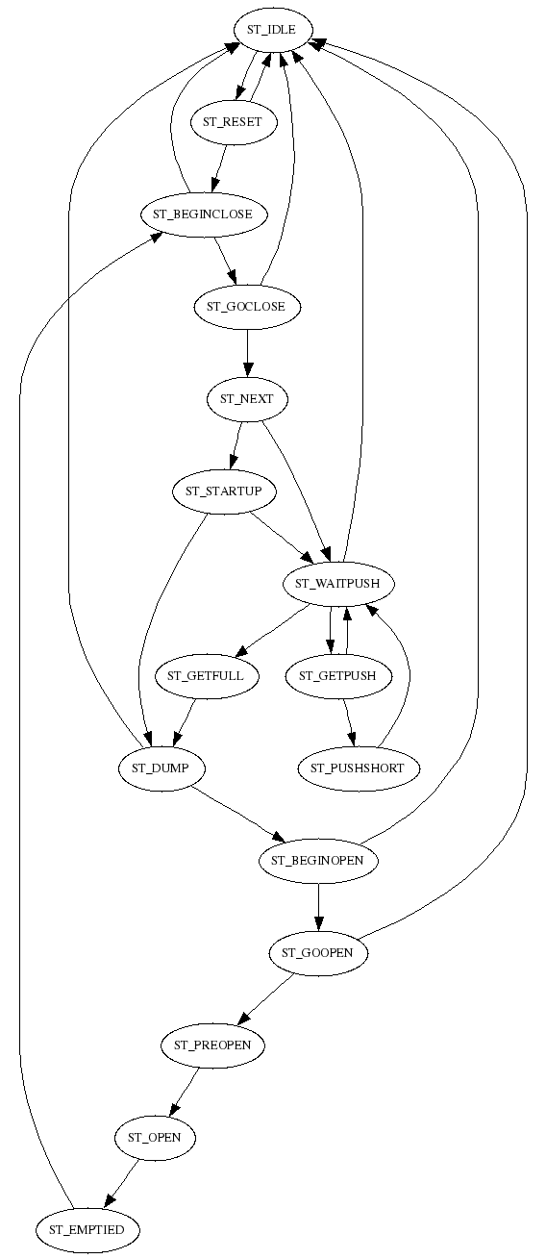fig 18: 708BufferPlads.statemachine
State=ST_BEGINOPEN
TEST CamGen = ST_START
SETSTATE ST_GOOPEN
ELSE
TEST Skubber = ST_IDLE
SETSTATE ST_IDLE
ENDTEST
ENDTEST
END

State=ST_GOOPEN
TEST CamGen = ST_STOP
SET full 0
SETSTATE ST_PREOPEN
ENDTEST
TEST CamGen = ST_NOCHOOSETRACK
OR CamGen = ST_IDLE
SETSTATE ST_IDLE
ENDTEST
END

State=ST_PREOPEN
TEST KasseLift = ST_READY2
OR KasseLift = ST_IDLE
TIMEOUT TimeOpen ST_OPEN
SETSTATE ST_OPEN
ENDTEST
END

State=ST_OPEN
TEST TimeOpen = 1
SETSTATE ST_EMPTIED
ENDTEST
END

State=ST_EMPTIED
SET emptyflag 1
TEST liftFree = 1
OR KasseLift = ST_IDLE
TEST CamGen = ST_CHOOSETRACK
SETSTATE ST_BEGINCLOSE
ENDTEST
ENDTEST
END

State=ST_BEGINCLOSE
SET kortskubleft1 0
SET kortskubleft2 0
SET kortskubright1 0
SET kortskubright2 0
TEST CamGen = ST_START
SETSTATE ST_GOCLOSE
ELSE
TEST Skubber = ST_IDLE
SETSTATE ST_IDLE
ENDTEST
ENDTEST
END

State=ST_GOCLOSE
TEST CamGen = ST_STOP
SETSTATE ST_NEXT
ENDTEST
TEST CamGen = ST_NOCHOOSETRACK
OR CamGen = ST_IDLE
SETSTATE ST_IDLE
ENDTEST
END

State=ST_NEXT
TEST kortskubleftinde = 1
AND kortskubrightinde = 1
TEST startingup = 0
SETSTATE ST_WAITPUSH
ELSE
SETSTATE ST_STARTUP
ENDTEST
ENDTEST
END

708ServoLift.statemachine
STATEMACHINEVERSION 3
Include=cpservolift.statemachine
Name=ServoLift
;** User section **
Const=posTop 345.0000

STATEMACHINEVERSION 3
Name=ServoLift
Link=Master KasseLift
Link=parent Parent
linkValue=firstRun WorkCell
linkValue=inShake Master
Output=home_vel "KasseLift Homevel"
Output=home_tq "KasseLift Hometorque"
Output=Mode "KasseLift Mode"
Output=setpoint "KasseLift MacSetpoint"
Output=vsoll "KasseLift Maxvel"
Output=asoll "KasseLift Maxacc"
Output=set_curpos "KasseLift Curpos"
Output=kvout "KasseLift Load Factor"
Output=tsoll "KasseLift Maxtorque"
Output=set_status "KasseLift Status"
;Output=reset_homedone "KasseLift Reset Home_Done"
Input=temperature "KasseLift Temperature"
Input=Inpos "KasseLift IN_POS"
Input=curpos "KasseLift Curpos"
Input=curtorque "KasseLift Curtorque"
Input=homedone "KasseLift HOME_DONE"
Input=curtsoll "KasseLift Maxtorque"
Input=status "KasseLift Status"
;Input=flwerr "KasseLift Follow Error"
;Input=fncerr "KasseLift Function Error"
Value=errorCode 0
Value=curpm 0.0
Const=loadfactor 3.0000
Value=homed 0
Value=temp 0
Const=home_speed -250.0000
Const=home_torque -50.0000
Const=acceleration 15000.0000
Const=cruise_speed 3000.0000
Const=testmode 0
Value=teststate 0
Value=distance 0.0
Value=startpos 0.0
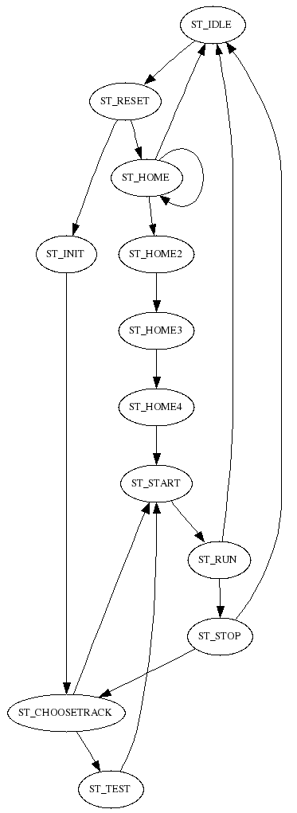fig 19: 708ServoLift.statemachine
Value=posf 0.0
Value=goIdle 0
Value=liftFree 1
Value=staticmode 0
;jogmode is controlled from formJogLiftUser.c
Value=jogmode 0
; tickspermotorround*gearudveksling/(eff_rad*2*pi)
; eks: 8000*13.3/(27.5*2*pi)
Const=tickspermm 615.7849434537
; All posXX in mm.
Const=posHome 10.0
;posShake > posFree
Const=posShake 70.0000
Const=posFree 60.0000
Const=posTop 378.0000
Const=posTestBegin 100.0000
Const=posTestEnd 157.0000
linkValue=item Program
Timeout=TimeTest 0
Timeout=TimeCmdDelay 500000
Timeout=TimeStartMax 1000000
Timeout=TimeHome 20000000
Timeout=TimeStatic 5000000

State=ST_TIMER
END

State=ST_HALT
END

State=ST_IDLE
TEST parent = ST_RESET
TEST status != 16
AND status != 32
AND status != 48
AND status != 64
AND status != 80
AND status != 0
; SET homed 0
SET set_status 0
ENDTEST
SET Mode 0
SET errorCode 0
TIMEOUT TimeCmdDelay ST_RESET
SETSTATE ST_TIMER
ENDTEST
END

State=ST_RESET
CALC posf = posTop - item.dy
CALC posf = posf - posFree
CALC posf = posf * tickspermm
SET kvout loadfactor
SET asoll acceleration
TEST homed = 0
SET home_vel home_speed
SET home_tq home_torque
SET temp 0
TIMEOUT TimeCmdDelay ST_HOME
SETSTATE ST_HOME
ELSE
SET vsoll cruise_speed
SET setpoint curpos
TIMEOUT TimeCmdDelay ST_INIT
SETSTATE ST_INIT
ENDTEST
END

State=ST_HOME
TEST temp = 0
AND TimeCmdDelay = 1
SET Mode 12
SET temp 1
TIMEOUT TimeCmdDelay ST_HOME
SETSTATE ST_HOME
ELSETEST temp = 1
AND TimeCmdDelay = 1
SET temp 2
TIMEOUT TimeHome ST_HOME
SETSTATE ST_HOME
ELSETEST temp = 2
TEST homedone = 1
SET homed 1
SET Mode 0
SET vsoll cruise_speed
TIMEOUT TimeCmdDelay ST_HOME2
SETSTATE ST_HOME2
ELSETEST TimeHome = 1
SET errorCode 1052
SET Mode 0
SETSTATE ST_IDLE
ENDTEST
ENDTEST
END

State=ST_HOME2
TEST TimeCmdDelay = 1
SET setpoint curpos
TIMEOUT TimeCmdDelay ST_HOME3
SETSTATE ST_HOME3
ENDTEST
END

State=ST_HOME3
TEST TimeCmdDelay = 1
SET Mode 2
TIMEOUT TimeCmdDelay ST_HOME4
SETSTATE ST_HOME4
ENDTEST
END

State=ST_HOME4
TEST TimeCmdDelay = 1
CALC setpoint = tickspermm * posHome
SET startpos curpos
CALC distance = setpoint - curpos
TIMEOUT TimeStartMax ST_START
SETSTATE ST_START
ENDTEST
END

State=ST_INIT
TEST TimeCmdDelay = 1
SET Mode 2
TIMEOUT TimeStatic ST_CHOOSETRACK
SETSTATE ST_CHOOSETRACK
ENDTEST
END

State=ST_NOCHOOSETRACK
END

State=ST_CHOOSETRACK
TEST Master = ST_BEGINHOME
CALC setpoint = tickspermm * posHome
SET startpos curpos
CALC distance = setpoint - curpos
TIMEOUT TimeStartMax ST_START
SETSTATE ST_START
ELSETEST Master = ST_BEGINHIGH
CALC temp = posTop - item.dy
TEST inShake = 1
CALC temp = temp - posShake
ENDTEST
CALC setpoint = tickspermm * temp
SET startpos curpos
CALC distance = setpoint - curpos
TIMEOUT TimeStartMax ST_START
SETSTATE ST_START
ELSETEST testmode = 1
TIMEOUT TimeTest ST_TEST
SETSTATE ST_TEST
ELSETEST staticmode = 0
AND TimeStatic = 1
SET Mode 0
SET staticmode 1
ENDTEST
TEST Master = ST_IDLE
AND testmode = 0
AND jogmode = 0
SET goIdle 1
CALC setpoint = tickspermm * posHome
SET startpos curpos
CALC distance = setpoint - curpos
TIMEOUT TimeStartMax ST_START
SETSTATE ST_START
ENDTEST
TEST curpos < posf
SET liftFree 1
ELSE
SET liftFree 0
ENDTEST
END

State=ST_TEST
TEST TimeTest = 1
TEST teststate = 0
SET teststate 1
CALC setpoint = tickspermm * posTestBegin
SET startpos curpos
CALC distance = setpoint - curpos
TIMEOUT TimeStartMax ST_START
SETSTATE ST_START
ELSETEST teststate = 1
SET teststate 0
CALC temp = posTop - item.dy
CALC setpoint = tickspermm * temp
;CALC setpoint = tickspermm * posTestEnd
SET startpos curpos
CALC distance = setpoint - curpos
TIMEOUT TimeStartMax ST_START
SETSTATE ST_START
ENDTEST
ENDTEST
TEST curpos < posf
SET liftFree 1
ELSE
SET liftFree 0
ENDTEST
END

State=ST_STOP
SET curpm 1000.0
TEST Master = ST_IDLE
AND goIdle = 1
SET goIdle 0
SET Mode 0
SETSTATE ST_IDLE
ELSE
TIMEOUT TimeStatic ST_CHOOSETRACK
SETSTATE ST_CHOOSETRACK
ENDTEST
END

State=ST_START
SET curpm 0.0
TEST staticmode = 1
SET Mode 2
SET staticmode 0
ENDTEST
TEST Inpos = 0
OR TimeStartMax = 1
SETSTATE ST_RUN
ENDTEST
TEST curpos < posf
SET liftFree 1
ELSE
SET liftFree 0
ENDTEST
END

State=ST_RUN
CALC curpm = curpos - startpos
CALC curpm = curpm / distance
CALC curpm = curpm * 1000.0
TEST Inpos = 1
SETSTATE ST_STOP
ENDTEST
TEST curpos < posf
SET liftFree 1
ELSE
SET liftFree 0
ENDTEST
TEST status != 16
AND status != 32
AND status != 48
AND status != 64
AND status != 80
AND status != 0
SET Mode 0
; SET homed 0
TIMEOUT TimeCmdDelay ST_IDLE
SETSTATE ST_TIMER
ENDTEST
END

708KasseLift.statemachine
STATEMACHINEVERSION 3
Include=cpkasselift.statemachine
Name=KasseLift
Output=Kassestop "KasseStop 1"
Link=CamGen ServoLift
;** User section **

STATEMACHINEVERSION 3
Name=KasseLift
;** Input **
;** Output **
Output=Centrer "KasseCentrer"
Output=Kassestop "dummyOut"
Output=Kassestop1 "dummyOut"
Output=Motor "KasseLift Conveyor Motor"
;** Link **
Link=CamGen CamGenLift
Link=parent Parent
Link=KasseInLiner
Link=BufferPlads
Link=next KasseLiftNext
Link=Foto KasseLiftFoto
Link=FotoFree KasseFreeFoto
Link=vibrator Vibrator
;** linkValue **
linkValue=firstRun WorkCell
linkValue=Fototest test Foto
linkValue=fotofree test FotoFree
linkValue=maxlayers PushPattern
linkValue=timeMotorInGoDown Program
linkValue=noShakeOnLast Program
linkValue=waitInR3 Program
linkValue=kasseStopType Program
linkValue=full BufferPlads
linkValue=emptyflag BufferPlads
linkValue=manuelt Program
linkValue=canSend recv1 next
linkValue=kassestoppos gostoppos ServoStop
Link=ServoStop
;** Table **
;** Item **
;** Const **
Const=centerOutInShake 0
Const=useFotoFree 0
;** Value **
Value=errorCode 0
Value=layers 0
Value=curshake 0
Value=reboot 0
Value=startingup 0
Value=inShake 0
Value=temp 0.0
Value=sending 0
Value=centered 0
Value=testmode 0
Value=simulate 0
;** Timeout **
Timeout=KStopDelay 2000000
Timeout=TimeStartUp 4000000
Timeout=TimeWaitShake 300000
Timeout=TimeSend 10000000
Timeout=TimePapMotor 0
Timeout=TimeW3 3000000
Timeout=testTime 3000000
Timeout=minSendTime 500000
Timeout=TimeCenter 1100000
Timeout=TimeInCenter 1000000
Timeout=timeCentrerOut 300000
Timeout=timeWaitForServoStop 2000000

; reboot = 0 -> ren rÃ¸v
; reboot = 1 -> starter med tom kasse
; reboot = 2 -> starter med fyldt kasse

State=ST_TIMER
END

State=ST_HALT
END

State=ST_IDLE
SET Centrer 0
SET kassestoppos 0
SET Kassestop 0
SET Kassestop1 0
SET Motor 0
TEST parent = ST_RESET
AND manuelt = 0
SETSTATE ST_RESET
ENDTEST
TEST simulate = 1
SETSTATE ST_RESET
ENDTEST
END

State=ST_RESET
SET errorCode 0
TEST firstRun = 1
SET reboot 0
SET layers 0
ENDTEST
SET curshake 0
SET inShake 0
SET startingup 1
SET Motor 0
TEST CamGen = ST_CHOOSETRACK
AND ServoStop != ST_HOME
AND ServoStop != ST_HOME2
AND ServoStop != ST_HOME3
AND ServoStop != ST_HOME4
TIMEOUT timeWaitForServoStop ST_BEGINHOME
SETSTATE ST_TIMER
ENDTEST
TEST parent = ST_IDLE
AND simulate = 0
SETSTATE ST_IDLE
ENDTEST
END

State=ST_STARTUP
SET startingup 0
TEST Foto = ST_OFF
TEST reboot = 1
SETSTATE ST_READY1
ELSE
TEST reboot = 2
TIMEOUT TimeW3 ST_READY
SETSTATE ST_READY
ELSE
TEST reboot = 0
TIMEOUT KStopDelay ST_PREPARE_SEARCHBOX
SETSTATE ST_PREPARE_SEARCHBOX
ENDTEST
ENDTEST
ENDTEST
ELSE
TEST Foto = ST_ON
TEST reboot = 0
SETSTATE ST_EMPTY
ELSE
TIMEOUT KStopDelay ST_PREPARE_SEARCHBOX
SETSTATE ST_PREPARE_SEARCHBOX
ENDTEST
ENDTEST
ENDTEST
TEST parent = ST_IDLE
AND simulate = 0
SETSTATE ST_IDLE
ENDTEST
END

State=ST_PREPARE_SEARCHBOX
SET Centrer 0
TEST kasseStopType = 1
SET Kassestop 1
SET Kassestop1 0
ELSETEST kasseStopType = 2
SET Kassestop 1
SET Kassestop1 1
ELSETEST kasseStopType = 3
SET kassestoppos 1
ENDTEST
TEST KStopDelay = 1
TIMEOUT TimeStartUp ST_SEARCHBOX
SETSTATE ST_SEARCHBOX
ENDTEST
END

State=ST_SEARCHBOX
SET Motor 1
TEST TimeStartUp = 1
SET reboot 0
SETSTATE ST_STARTUP
ENDTEST
TEST Fototest = 0
TEST simulate = 1
SETSTATE ST_SEND
ELSE
SET reboot 1
SETSTATE ST_STARTUP
ENDTEST
ENDTEST
TEST parent = ST_IDLE
AND simulate = 0
SETSTATE ST_IDLE
ENDTEST
END

State=ST_EMPTY
SET Centrer 0
TEST kasseStopType = 1
SET Kassestop 1
SET Kassestop1 0
ELSETEST kasseStopType = 2
SET Kassestop 1
SET Kassestop1 1
ELSETEST kasseStopType = 3
SET kassestoppos 1
ENDTEST
TEST KasseInLiner = ST_SEND
SET Motor 1
SET centered 0
TIMEOUT TimeCenter ST_RECEIVE
SETSTATE ST_RECEIVE
ELSE
SET Motor 0
ENDTEST
TEST parent = ST_IDLE
AND simulate = 0
SETSTATE ST_IDLE
ENDTEST
END

State=ST_RECEIVE
SET Motor 1
TEST centered = 0
TEST TimeCenter = 1
SET Centrer 1
SET centered 1
TIMEOUT TimeInCenter ST_RECEIVE
SETSTATE ST_RECEIVE
ENDTEST
ELSE
TEST TimeInCenter = 1
AND centered = 1
SET Centrer 0
SET centered 2
ENDTEST
ENDTEST
TEST Fototest = 0
SET Centrer 1
SET Motor 0
SET reboot 1
TEST simulate = 1
SETSTATE ST_SEND
ELSE
SETSTATE ST_READY1
ENDTEST
ENDTEST
TEST KasseInLiner = ST_IDLE
SETSTATE ST_IDLE
ENDTEST
END

State=ST_READY1
SET Motor 0
SET Centrer 1
TEST CamGen = ST_CHOOSETRACK
SETSTATE ST_BEGINHIGH
ENDTEST
TEST parent = ST_IDLE
AND simulate = 0
SETSTATE ST_IDLE
ENDTEST
END

State=ST_READY2
SET kassestoppos 0
SET Kassestop 0
SET Kassestop1 0
TEST BufferPlads = ST_OPEN
CALC layers = layers + 1
TEST layers >= maxlayers
SET layers 0
ENDTEST
SETSTATE ST_SHAKE1
ENDTEST
TEST parent = ST_IDLE
AND simulate = 0
SETSTATE ST_IDLE
ENDTEST
END

State=ST_SHAKE1
TEST layers = 0
AND noShakeOnLast = 1
SETSTATE ST_SHAKEDONE
ELSE
TEST CamGen = ST_CHOOSETRACK
SET inShake 1
TEST centerOutInShake = 1
SET Centrer 0
ENDTEST
SETSTATE ST_BEGINHIGH
ELSE
TEST CamGen = ST_NOCHOOSETRACK
OR CamGen = ST_IDLE
SETSTATE ST_IDLE
ENDTEST
ENDTEST
ENDTEST
END

State=ST_SHAKE2
TEST emptyflag = 1
TIMEOUT TimeWaitShake ST_SHAKE3
SETSTATE ST_SHAKE3
ENDTEST
END

State=ST_SHAKE3
TEST TimeWaitShake = 1
SET inShake 2
TEST CamGen = ST_CHOOSETRACK
SETSTATE ST_BEGINHIGH
ELSE
TEST CamGen = ST_NOCHOOSETRACK
OR CamGen = ST_IDLE
SETSTATE ST_IDLE
ENDTEST
ENDTEST
ENDTEST
END

State=ST_SHAKEDONE
SET inShake 0
TEST centerOutInShake = 1
SET Centrer 1
ENDTEST
TEST layers = 0
SET reboot 2
SETSTATE ST_GODOWN
ELSE
SETSTATE ST_READY2
ENDTEST
END

State=ST_GODOWN
TEST timeMotorInGoDown != 0
SET Centrer 0
ENDTEST
TEST CamGen = ST_CHOOSETRACK
SET TimePapMotor timeMotorInGoDown
TIMEOUT TimePapMotor ST_BEGINHOME
SETSTATE ST_BEGINHOME
ELSE
TEST CamGen = ST_NOCHOOSETRACK
OR CamGen = ST_IDLE
SETSTATE ST_IDLE
ENDTEST
ENDTEST
END

State=ST_READY
SET kassestoppos 0
SET Kassestop 0
SET Kassestop1 0
TEST vibrator = ST_GO
SET Centrer 1
ELSE
SET Centrer 0
ENDTEST
TEST waitInR3 = 0
OR TimeW3 = 1
TEST next = ST_EMPTY
AND canSend = 1
SET Centrer 0
TIMEOUT timeCentrerOut ST_SEND
SETSTATE ST_SEND
ENDTEST
ENDTEST
TEST parent = ST_IDLE
AND simulate = 0
SETSTATE ST_IDLE
ENDTEST
END

State=ST_SEND
TEST sending = 0
SET Centrer 0
TEST timeCentrerOut = 1
TEST next = ST_RECEIVE
OR simulate = 1
SET sending 1
SET Motor 1
TIMEOUT minSendTime ST_SEND
SETSTATE ST_SEND
ENDTEST
ENDTEST
ELSE
TEST sending = 1
TEST minSendTime = 1
SET sending 2
TIMEOUT TimeSend ST_SEND
SETSTATE ST_SEND
ENDTEST
ELSE
TEST sending = 2
TEST Fototest = 1
AND useFotoFree = 0
SET sending 0
SET reboot 0
SETSTATE ST_EMPTY
ENDTEST
TEST fotofree = 1
AND useFotoFree = 1
SET sending 0
SET reboot 0
SETSTATE ST_EMPTY
ENDTEST
TEST TimeSend = 1
SET sending 0
SET errorCode 1014
SETSTATE ST_IDLE
ENDTEST
ENDTEST
ENDTEST
ENDTEST
END

State=ST_BEGINHOME
TEST CamGen = ST_START
SETSTATE ST_GO
ELSE
TEST CamGen = ST_NOCHOOSETRACK
OR CamGen = ST_IDLE
SETSTATE ST_IDLE
ENDTEST
ENDTEST
END

State=ST_TESTMODE
TEST testTime = 1
AND CamGen = ST_CHOOSETRACK
SET startingup 0
SET inShake 0
SET reboot 2
SETSTATE ST_BEGINHOME
ENDTEST
TEST parent = ST_IDLE
AND simulate = 0
SETSTATE ST_IDLE
ENDTEST
END

State=ST_BEGINHIGH
TEST CamGen = ST_START
TEST testmode = 1
TIMEOUT testTime ST_TESTMODE
SETSTATE ST_TESTMODE
ELSE
SETSTATE ST_GO
ENDTEST
ELSE
TEST CamGen = ST_NOCHOOSETRACK
OR CamGen = ST_IDLE
SETSTATE ST_IDLE
ENDTEST
ENDTEST
END

State=ST_GO
TEST reboot = 2
CALC temp = timeMotorInGoDown * 0.8
TEST TimePapMotor < temp
SET Motor 1
ENDTEST
TEST TimePapMotor = 1
SET Motor 0
ENDTEST
ENDTEST
TEST CamGen = ST_STOP
TEST startingup = 1
SETSTATE ST_STARTUP
ELSE
TEST inShake = 1
SETSTATE ST_SHAKE2
ELSE
TEST inShake = 2
SETSTATE ST_SHAKEDONE
ELSE
TEST reboot = 1
SETSTATE ST_READY2
ELSE
TEST reboot = 2
SET Motor 0
TIMEOUT TimeW3 ST_READY
SETSTATE ST_READY
ENDTEST
ENDTEST
ENDTEST
ENDTEST
ENDTEST
ENDTEST
TEST CamGen = ST_NOCHOOSETRACK
OR CamGen = ST_IDLE
SETSTATE ST_IDLE
ENDTEST
END

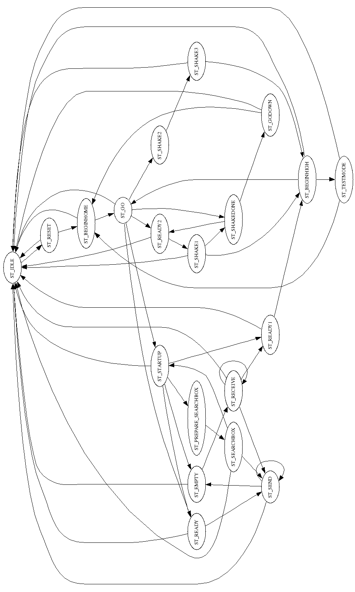fig 20: 708KasseLift.statemachine

Kasse Handling Statemachines

708KasseLiftNext.statemachine
STATEMACHINEVERSION 3
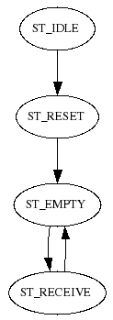fig 21: 708KasseLiftNext.statemachine
Name=KasseLiftNext
Link=prev KasseLift
Value=recv1 1

State=ST_TIMER
END

State=ST_HALT
END

State=ST_IDLE
SETSTATE ST_RESET
END

State=ST_RESET
SETSTATE ST_EMPTY

END

State=ST_EMPTY
TEST prev = ST_SEND
SETSTATE ST_RECEIVE
ENDTEST
END

State=ST_RECEIVE
TEST prev != ST_SEND
SETSTATE ST_EMPTY
ENDTEST
END

708KasseLiftFoto.statemachine
STATEMACHINEVERSION 3
Include=input.statemachine
Name=KasseLiftFoto
Input=input "KasseLift Foto"
Timeout=TimeOn 250000
Timeout=TimeOff 650000
Value=test 0
Link=parent Parent

708KasseLoaderFoto.statemachine
STATEMACHINEVERSION 3
Include=fotoinput.statemachine
Name=KasseLoaderFoto
Input=input "KasseLoader Foto"
Timeout=blockTime 700000
Timeout=freeTime 100000
Value=test 0
Const=free 1
Const=blocked 0

STATEMACHINEVERSION 3
Name=FotoInput
Input=input "dummyOff"
Timeout=blockTime 100000
Timeout=freeTime 100000
Value=test 0
Const=free 0
Const=blocked 1

State=ST_HALT
SETSTATE ST_IDLE
END

State=ST_TIMER
END

State=ST_IDLE
TEST input = blocked
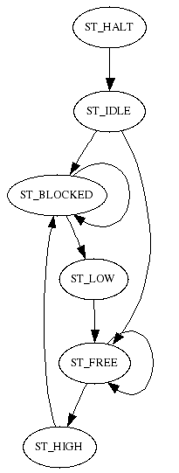fig 22: fotoinput.statemachine
SET test blocked
SETSTATE ST_BLOCKED
ELSE
TEST input = free
SET test free
SETSTATE ST_FREE
ENDTEST
ENDTEST
END

State=ST_FREE
TEST input = blocked
AND test = free
SET test blocked
TIMEOUT blockTime ST_FREE
SETSTATE ST_FREE
ENDTEST
TEST input = blocked
AND test = blocked
AND blockTime = 1
SETSTATE ST_HIGH
ENDTEST
TEST input = free
SET test free
ENDTEST
END

State=ST_HIGH
SETSTATE ST_BLOCKED
END

State=ST_BLOCKED
TEST input = free
AND test = blocked
SET test free
TIMEOUT freeTime ST_BLOCKED
SETSTATE ST_BLOCKED
ENDTEST
TEST input = free
AND test = free
AND freeTime = 1
SETSTATE ST_LOW
ENDTEST
TEST input = blocked
SET test blocked
ENDTEST
END

State=ST_LOW
SETSTATE ST_FREE
END

708KasseLoader.statemachine
STATEMACHINEVERSION 3
Name=KasseLoader
Output=motor "KasseLoader Motor"
Output=skubber "KasseSkubber1"
;minihack: if Kasseloader doesn't have a stopper set it to any or empty output and set hasStopper = 0, the output will then not be set
linkValue=firstRun WorkCell
Link=skubberReceiver KasseInLiner
;conveyorReceiver only used if hasStopper = 1
Link=conveyorReceiver KasseLoader
Link=foto KasseLoaderFoto
Const=hasStopper 0
;whether or not prev sends from side or back of KasseLoader
Const=sideReceive 0
Timeout=skubberTime 200000
Timeout=motorStopTime 600000
Timeout=maxReceiveTime 999999999
Timeout=startupTime 3000000
Value=gotCase 0
Link=parent Parent

State=ST_GOBACK
SET skubber 0
TEST foto = ST_FREE
SETSTATE ST_EMPTY
ENDTEST
END

State=ST_TIMER
END

State=ST_HALT
END

State=ST_IDLE
SET skubber 0
SET motor 0
TEST parent = ST_RESET
SETSTATE ST_RESET
ENDTEST
END

State=ST_RESET
TEST foto = ST_BLOCKED
TIMEOUT motorStopTime ST_READY
SETSTATE ST_READY
ELSE
TEST foto = ST_FREE
TIMEOUT startupTime ST_STARTUP
SETSTATE ST_STARTUP
ENDTEST
ENDTEST
END

State=ST_STARTUP
TEST firstRun = 1
OR gotCase = 1
TEST startupTime = 1
SETSTATE ST_EMPTY
ELSE
TEST foto = ST_BLOCKED
TIMEOUT motorStopTime ST_READY
SETSTATE ST_READY
ELSE
SET motor 1
ENDTEST
ENDTEST
ELSE
SETSTATE ST_EMPTY
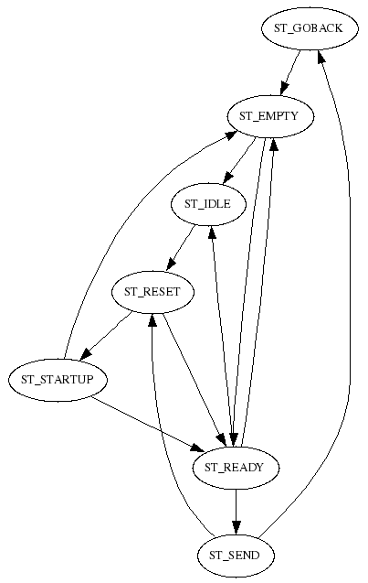fig 23: 708KasseLoader.statemachine
ENDTEST
END

State=ST_EMPTY
SET skubber 0
SET motor 1
TEST foto = ST_BLOCKED
TIMEOUT motorStopTime ST_READY
SETSTATE ST_READY
ENDTEST
TEST parent = ST_IDLE
SETSTATE ST_IDLE
ENDTEST
END

State=ST_SEND
SET skubber 1
TEST skubberReceiver != ST_RECEIVE1
AND skubberReceiver != ST_RECEIVE2
AND skubberReceiver != ST_RECEIVE3
AND skubberTime = 1
SET gotCase 0
TIMEOUT skubberTime ST_GOBACK
SETSTATE ST_GOBACK
ENDTEST
TEST skubberReceiver = ST_IDLE
SETSTATE ST_RESET
ENDTEST
END

State=ST_READY
SET skubber 0
SET motor 0
SET gotCase 1
TEST skubberReceiver = ST_EMPTY
TIMEOUT skubberTime ST_SEND
SETSTATE ST_SEND
ELSE
TEST foto = ST_FREE
SETSTATE ST_EMPTY
ENDTEST
ENDTEST
TEST parent = ST_IDLE
AND motorStopTime = 1
SETSTATE ST_IDLE
ENDTEST
END

708KasseInLiner.statemachine
STATEMACHINEVERSION 3
Include=cpkasseinliner.statemachine
Name=KasseInLiner
Link=prevback KasseInLiner
Link=prevleft KasseLoader
Link=prevright KasseInLiner
;** User Section **

STATEMACHINEVERSION 3
Name=KasseInLiner
;** Input **
;** Output **
Output=Motor "KasseInLiner Motor"
;** Link **
Link=prevback KasseInLinerPrevBack
Link=prevleft KasseInLinerPrevLeft
Link=prevright KasseInLinerPrevRight
Link=CamGen CamGenLift
Link=parent Parent
Link=KasseLift
Link=Foto KasseInLinerFoto
;** linkValue **
linkValue=Fototest test Foto
linkValue=loadfromleft Program
linkValue=loadfromright Program
linkValue=noShakeOnLast Program
;** Table **
;** Item **
;** Const **
Const=speedSend 0
Const=useMaxReceive 1
;** Value **
Value=errorCode 0
Value=simulate 0

linkValue=manuelt Program
;** Timeout **
Timeout=TimeStartUp 1000000
Timeout=TimeMaxSend 8000000
Timeout=TimeMaxReceive 8000000
Timeout=noShakeOnLastWaitSendTime 300000

State=ST_TIMER
END

State=ST_HALT
END

State=ST_IDLE
SET Motor 0
TEST parent = ST_RESET
AND manuelt = 0
SET errorCode 0
SETSTATE ST_RESET
ENDTEST
TEST simulate = 1
SETSTATE ST_RESET
ENDTEST
END

State=ST_RESET
TIMEOUT TimeStartUp ST_STARTUP
SETSTATE ST_STARTUP
END

State=ST_STARTUP
TEST TimeStartUp = 1
TEST Fototest = 0
SETSTATE ST_READY
ELSE
SETSTATE ST_EMPTY
ENDTEST
ENDTEST
END

State=ST_EMPTY
SET Motor 0
TEST loadfromleft = 1
AND prevleft = ST_SEND
TIMEOUT TimeMaxReceive ST_RECEIVE1
SETSTATE ST_RECEIVE1
ELSE
TEST loadfromright = 1
AND prevright = ST_SEND
TIMEOUT TimeMaxReceive ST_RECEIVE2
SETSTATE ST_RECEIVE2
ELSE
TEST prevback = ST_SEND
TIMEOUT TimeMaxReceive ST_RECEIVE3
SETSTATE ST_RECEIVE3
ENDTEST
ENDTEST
ENDTEST
TEST parent = ST_IDLE
AND simulate = 0
SETSTATE ST_IDLE
ENDTEST
END

State=ST_RECEIVE1
TEST TimeMaxReceive = 1
SET errorCode 1006
SETSTATE ST_IDLE
ENDTEST
TEST Fototest = 0
SETSTATE ST_READY
ENDTEST
END

State=ST_RECEIVE2
TEST TimeMaxReceive = 1
SET errorCode 1006
SETSTATE ST_IDLE
ENDTEST
TEST Fototest = 0
SETSTATE ST_READY
ENDTEST
END

State=ST_RECEIVE3
SET Motor 1
TEST TimeMaxReceive = 1
AND useMaxReceive = 1
SET errorCode 1006
SETSTATE ST_IDLE
ENDTEST
TEST Fototest = 0
SETSTATE ST_READY
ENDTEST
TEST parent = ST_IDLE
AND simulate = 0
AND useMaxReceive = 0
SETSTATE ST_IDLE
ENDTEST
END

State=ST_READY
SET Motor 0
TEST Fototest = 1
SETSTATE ST_EMPTY
ELSE
TEST KasseLift = ST_EMPTY
TIMEOUT TimeMaxSend ST_SEND
SETSTATE ST_SEND
ELSE
TEST noShakeOnLast = 1
AND speedSend = 1
TEST KasseLift = ST_SEND
TIMEOUT noShakeOnLastWaitSendTime ST_WAIT_SEND
SETSTATE ST_WAIT_SEND
ENDTEST
ENDTEST
ENDTEST
ENDTEST
TEST parent = ST_IDLE
AND simulate = 0
SETSTATE ST_IDLE
ENDTEST
END

State=ST_WAIT_SEND
TEST noShakeOnLastWaitSendTime = 1
TIMEOUT TimeMaxSend ST_SEND
SETSTATE ST_SEND
ENDTEST
END

State=ST_SEND
TEST KasseLift = ST_SEND
TEST noShakeOnLast = 1
SET Motor 1
ENDTEST
ELSE
TEST KasseLift = ST_RECEIVE
SET Motor 1
ELSE
SET Motor 0
ENDTEST
ENDTEST
TEST KasseLift != ST_RECEIVE
AND Fototest = 1
SETSTATE ST_EMPTY
ENDTEST
TEST TimeMaxSend = 1
SET errorCode 1012
SETSTATE ST_IDLE
ENDTEST
END
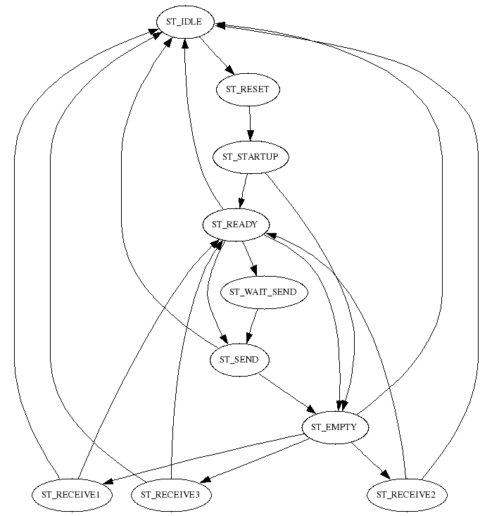fig 24: 708KasseInLiner.statemachine

708KasseInLinerFoto.statemachine
STATEMACHINEVERSION 3
Include=input.statemachine
Name=KasseInLinerFoto
Input=input "KasseInLiner Foto"
Timeout=TimeOn 1000000
Timeout=TimeOff 700000
Value=test 0
Link=parent Parent

708Vibrator.statemachine
STATEMACHINEVERSION 3
Include=cpvibrator.statemachine
Name=Vibrator
;** User section **

STATEMACHINEVERSION 3
Name=Vibrator
Output=Vibrator "KasseLift Vibrator"
Link=KasseLift
Link=parent Parent
linkValue=vibrateTime Program
Timeout=TimeVibrate 20000000

State=ST_TIMER
END

State=ST_HALT
END

State=ST_IDLE
SET Vibrator 0
TEST parent = ST_RESET
SETSTATE ST_RESET
ENDTEST
END
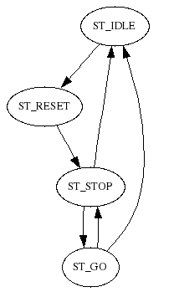fig 25: 708Vibrator.statemachine
State=ST_RESET
SET TimeVibrate vibrateTime
SET Vibrator 0
SETSTATE ST_STOP
END

State=ST_STOP
SET Vibrator 0
TEST KasseLift = ST_SHAKE1
TIMEOUT TimeVibrate ST_GO
SETSTATE ST_GO
ENDTEST
TEST parent = ST_IDLE
SETSTATE ST_IDLE
ENDTEST
END

State=ST_GO
SET Vibrator 1
TEST TimeVibrate = 1
OR KasseLift = ST_SEND
SETSTATE ST_STOP
ENDTEST
TEST parent = ST_IDLE
SETSTATE ST_IDLE
ENDTEST
END

708
;*********************************

;* COMMON *
;*********************************
ITEM D9.item
ITEM C11.item
ITEM C14.item
ITEM C18.item
ITEM HSdoubleD9Cardboard.item
CPPATTERN Harndrup.cppattern
CPPATTERN DobbeltD9.cppattern
CPPATTERN C11Small8.cppattern
STATETEKST danish.statetekst

STATETEKST english.statetekst
STATETEKST spanish.statetekst
LANGUAGE danish.language
LANGUAGE english.language
LANGUAGE spanish.language
;*********************************
;* CP6000 V4 *
;*********************************
DIO 708.io
COMSK 708.comsk
MAC 708Skub.mac
MAC 708Buffer.mac
MAC 708Lift.mac

